**"Database Training" course report**

**(Semester 2 of the 2022-2023 academic year)**

**Academic report lecture information capture**

**Submission date： 2023/ 7/ 7**

|  |  |  |  |  |  |
| --- | --- | --- | --- | --- | --- |
| **College** | **College of Future Technology** | | **Professional and class** | **Data Science and Big Data Technology Class 1** | |
| **Course title** | **Database training** | | **Teacher** | **Zeng bin** | |
| **Number of people** | **4** | |  |  | |
| **Student number** | | **Student name** | | | **Score** |
| **202130381015** | | **Yang Jiarui** | | |  |
| **202130131658** | | **Li Shengyang** | | |  |
| **202130134246** | | **Zhang chi** | | |  |
| **202130090047** | | **Chen shuo** | | |  |
| **Teacher Comments:**  **Teacher's signature:** | | | | | |

Catalogue

**Demand Analysis3**

**Summary Design3**

Front-end 4

Back-end4

**Detailed Design 4**

Crawler design4

Extract relevant lecture website 5

Extract key information 6

Text recognition of pictures 8

Web and database design 9

Machine learning classification and algorithm design 15

Data processing15

Selection of pretreatment model 16

Model training and processing 19

Model prediction 20

**Software testing 21**

**Software demonstration 21**

**Software use tutorial 26**

**Summary of group discussion30**

**Personal Summary33**

**Project Schedule34**

# 1 Demand Analysis

As for the topic of information capture in academic reports, our team has made a demand analysis on it, and at the same time, we also talked and asked other personnel accordingly, and watched other videos of similar results. Through our research, we have analyzed the following demands:

1. First of all, as required by the task book, our academic report lectures must be rich and the amount of data should be sufficient. Therefore, based on the six websites provided, we decided to broaden the scope of our sampling from time to time, and all the academic report lectures within at least five years were extracted.

2. Some academic lectures published on the website of some schools are based on pictures, but in the information capture of academic report lectures, people want to see more direct text information from the website, so we need to provide the function of image recognition and text extraction at the back end.

3, in the observation of other websites, we found that people in the content of the success, will search and filter and sort for a certain feature, accordingly, we also need to provide in our software for the sorting of attributes and search functions.

4. There are different disciplines in academic reports, and the span of different disciplines is relatively large. Students of this major prefer to obtain the information of academic reports and lectures of this major, but this information is not provided on the actual website.

5, the website should be accessible to the outside world, so that it can become a product, so we need to complete the Intranet penetration work, so that the internal and external network can be accessed.。

# 2 Summary Design

System function diagram:

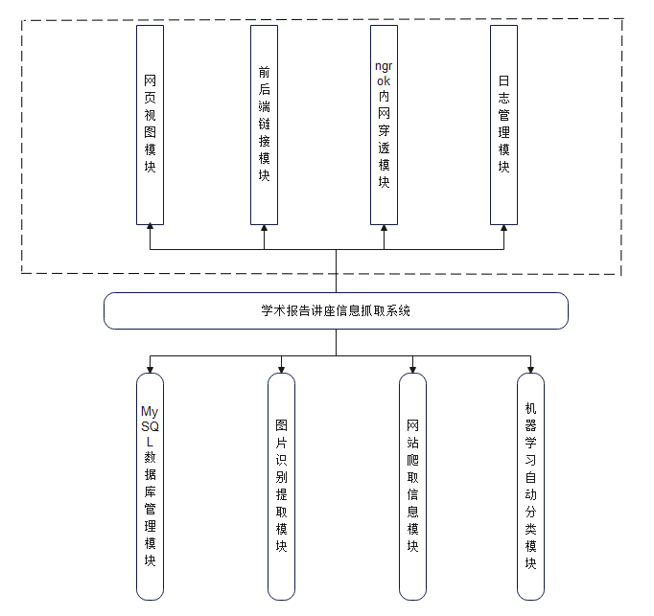

Functional analysis:

## 2.1. Front end:

Web view module: responsible for the front-end interface design combined with html, css, javascript and other front-end languages, and provide date picker, page number design and other components responsible for beautifying the web interface.

Back-end link module: Using Django framework, web pages and databases are integrated into it, so that front-end query operations can be linked to back-end database SQL query statements.

Ngrok Intranet penetration module: Uses ngrok to establish a secure channel between the public endpoint and the local web server to achieve Intranet penetration, upload the Intranet to the public network, and provide external access.

Log management system: store user behavior and code anomalies, using SqlLog to record SQL query statements, database table names and other indicators. And the behavior that happens on the front end.

## 2.2. Back end:

MySQL database management module: responsible for writing SQL statements to complete the search and other work, data table construction and other management.

Image recognition and extraction module: Using the PaddleORC api interface, the climbed image data was analyzed and the text module was extracted, which was stored in the MySQL database according to attributes.

Web crawling information module: Using python to crawl data from six websites and standardize the format and coding of the data, using python language to connect to the MySQL database for storage.

Machine learning automatic classification module: fine-tune the model according to the given data, and store the data into the trained model, make predictions on it, and obtain classification results.。

# Detailed Design

## 3.1 Crawler design：

Crawler design principles:

Since the task of this project is to extract all the lecture information under the specified website and carry out corresponding operations on it, it is very important to crawl the lecture information under each website.

Here, the design principle we follow is to grab the lecture notice link of each website under the assignment book, and then grab the lecture information under each link, some of which are presented in the form of pictures. Finally, for each lecture notice, we extract relevant features one by one. This process is realized through the program code, and there is no manual modification and addition and deletion.

Technical route design:

Since the format of notifications is very different, we decided to design a crawler for every website. The following is the overall design flow chart of the crawler part of our group.

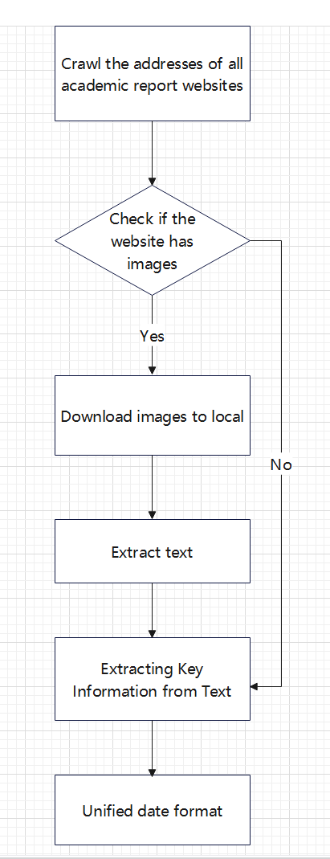

1) Extract relevant lecture website

Each school's website has a directory of academic presentations, through which you can crawl the urls of all academic presentations that need to be processed.

Call the get_all_list() function to automatically fetch all urls and store them in url.csv.



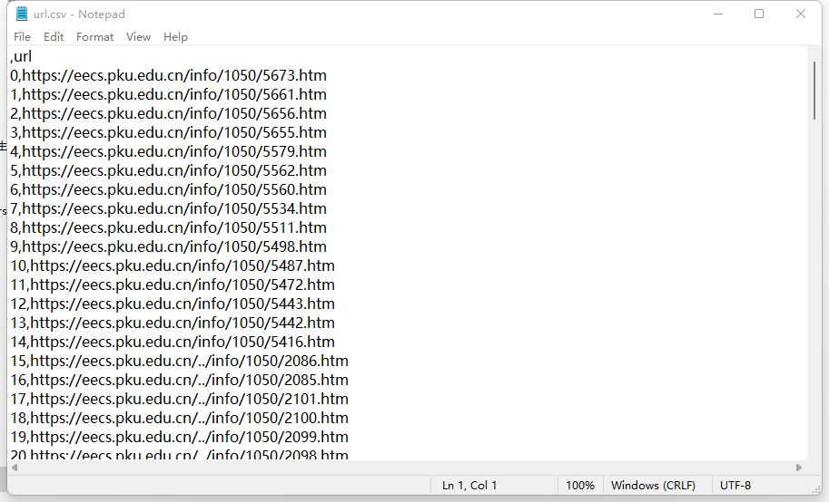

2) Extract key information

Since the web pages of different schools are produced in different formats and the key information is located in different regions, we have learned about the internal construction results of the web pages. We first extracted all the information of lectures through request database, and then adjusted the format by BeautifulSoup database. The regularization method is adopted to extract the relevant features.

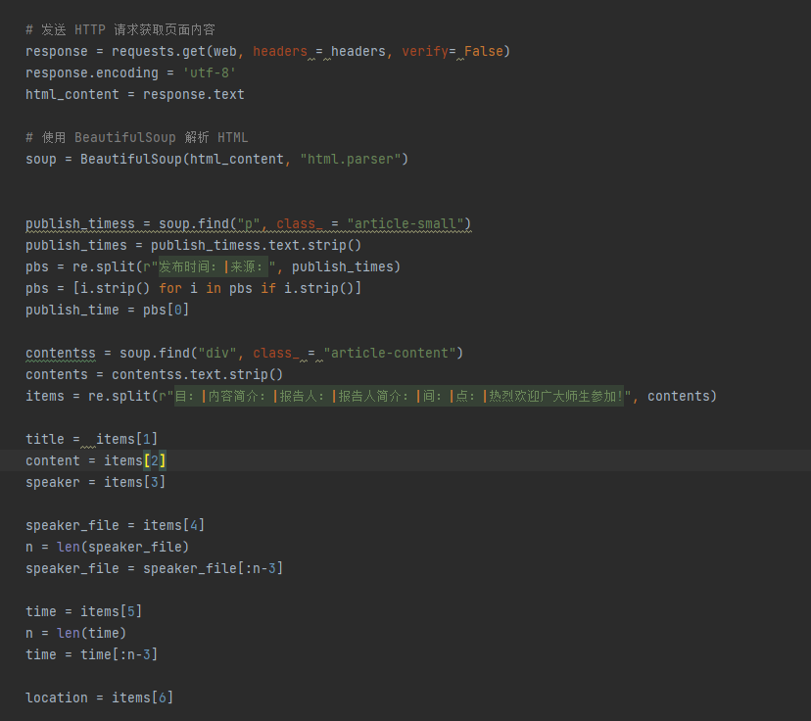

After the completion of the unified format of the web page crawling, there are still many strange format of the web page, the reason behind it is that the preparation of lecture notice personnel are different, their preferences and habits in the preparation of notice are also different. In order to effectively extract the features of these lectures with different formats, we consider adding a feature search, that is, searching for a single feature. For example, in Peking University, the position of the speaker may appear before or after the lecture time, and even there are no speakers in some forums. Therefore, our team came up with the idea of conducting a single search for each feature, that is, finding only one target feature from the lecture information crawled down each time, and repeating until the search is complete, so as to solve the problem of different positions.

In the final stage of the text crawler, there is still a problem that the key words under the lecture notice of some websites are too diverse. And these constantly changing features, a variety of expressions, to our search for features to add a lot of difficulties. For example, for the characteristic information of the Speaker, its characteristic keywords may be a variety of expressions such as lecturer, speaker, lecturer, reporter, presenter, professor, doctor, speaker, etc. Therefore, to solve this problem, our group uses the multi-match flag search method under a single feature, and takes the identifier with high frequency as the keyword. The lecture notification content was matched line by line to see if there was a match with the keywords we set, and then solved this difficulty, and finally the extraction accuracy of this approach reached more than 90%.

This part can call the prase_info(url, id) function to extract key information. The seize_from_key(text, all_key, id) function matches the seize_from_key feature in all_key from text.

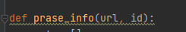

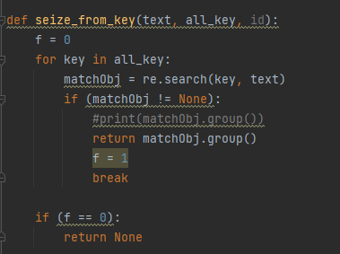

The results are as follows:



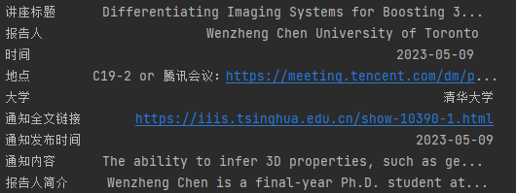

3) Text recognition of pictures

The difficulty of lecture information crawler in the form of pictures is to extract lecture information from pictures. In general, we are divided into three stages to carry out the implementation, which is to download the lecture pictures from the website to the local, identify the text in the pictures and extract the key information.

For the image download section, we choose to use the urlretrieve of the urllib library to download all the lecture images locally. Here, call prase_page(url, index). Images in the url will be placed in the Images folder.

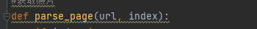

For text extraction, at the beginning, our group used EasyOCR library to extract, but the recognition effect was not ideal. Later, PaddleOCR library was used to extract text, and the accuracy rate was improved to about 98%. At the same time, PaddleOCR also provided the position of the image where the text was located, which facilitated paragraph planning. Here, you can directly call get_words(img, index), and put the text into the corresponding csv file after the call.

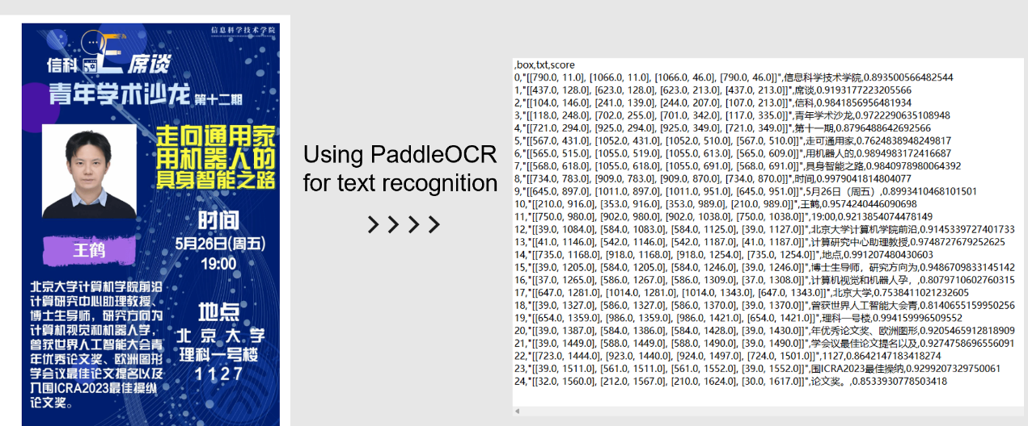

In the final stage of the image crawler, there is a problem that the text in the picture cannot be arranged in the correct order. Therefore, the first step is to sort out the order of the text. In this step, our group classifies the text according to the position of the text in the picture. Then is the extraction of key information, this step is mainly completed by using regular expressions to find keywords, such as to find information about the time, to match similar "... The year of.. Month... Keywords such as "day" (see Extract Key information section for details), and finally put these extracted information into the csv file. Here you need to call seize_from_graph(id, graph_id, ret).



## 3.2. Web and database design:

Front and rear end links:

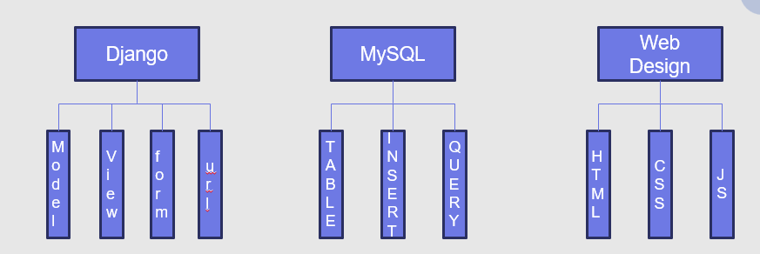

Front-end design:

The front-end design adopts the classic html+JavaScript+css pattern. Among them, we also use the date selector, word format limit, page number design and other components.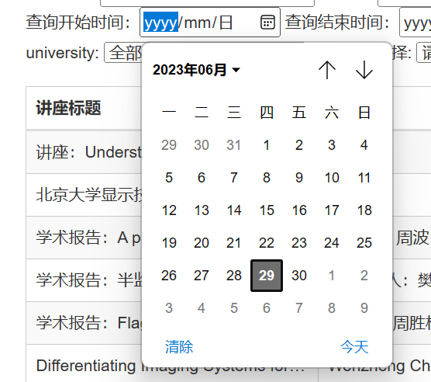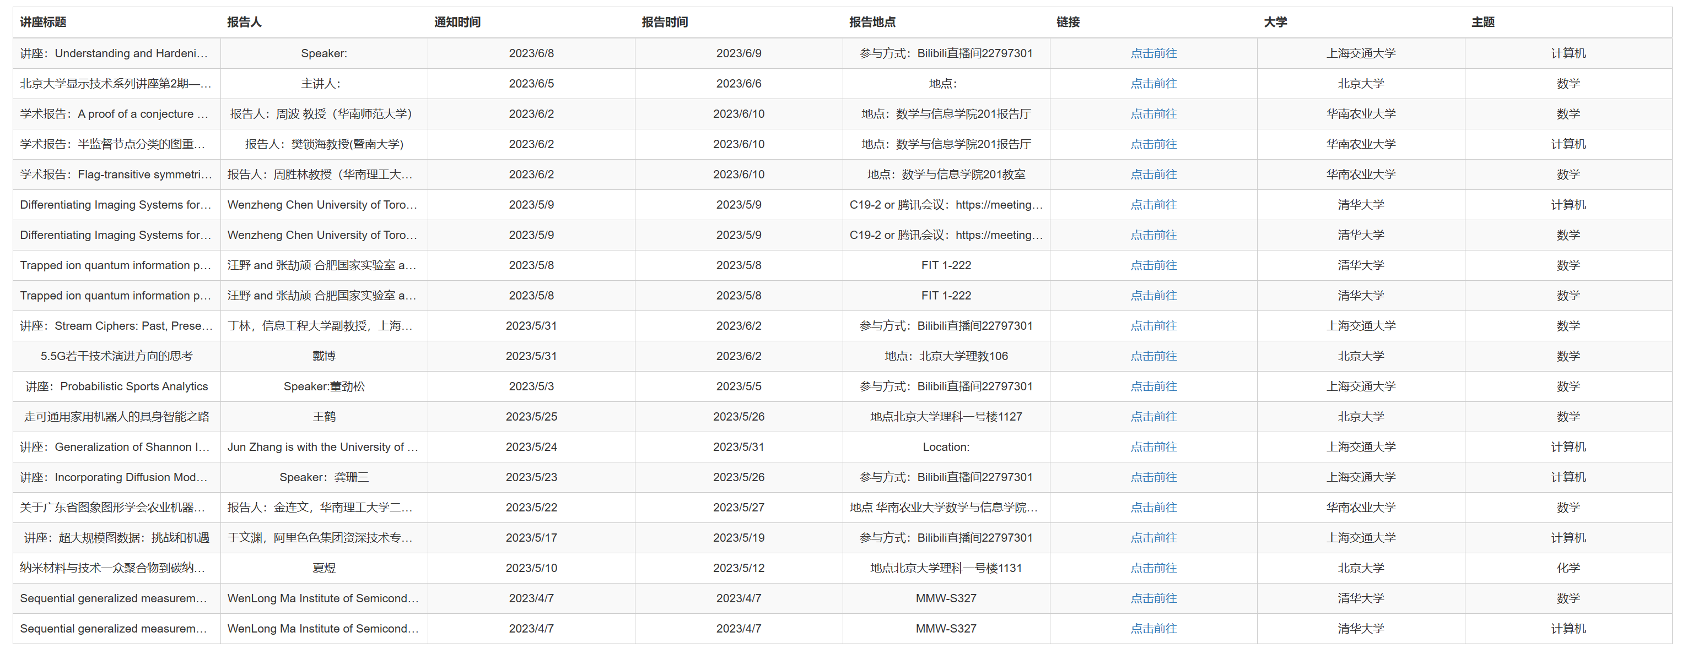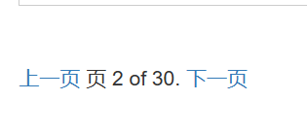

Back-end storage:

At the back end, we use mysql database for storage. Here we use python statements to read the crawled csv file into the database.

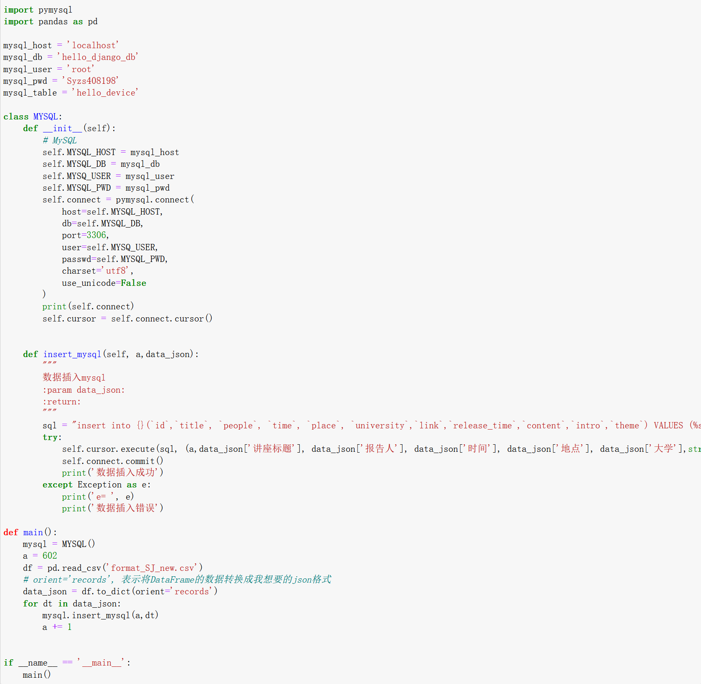

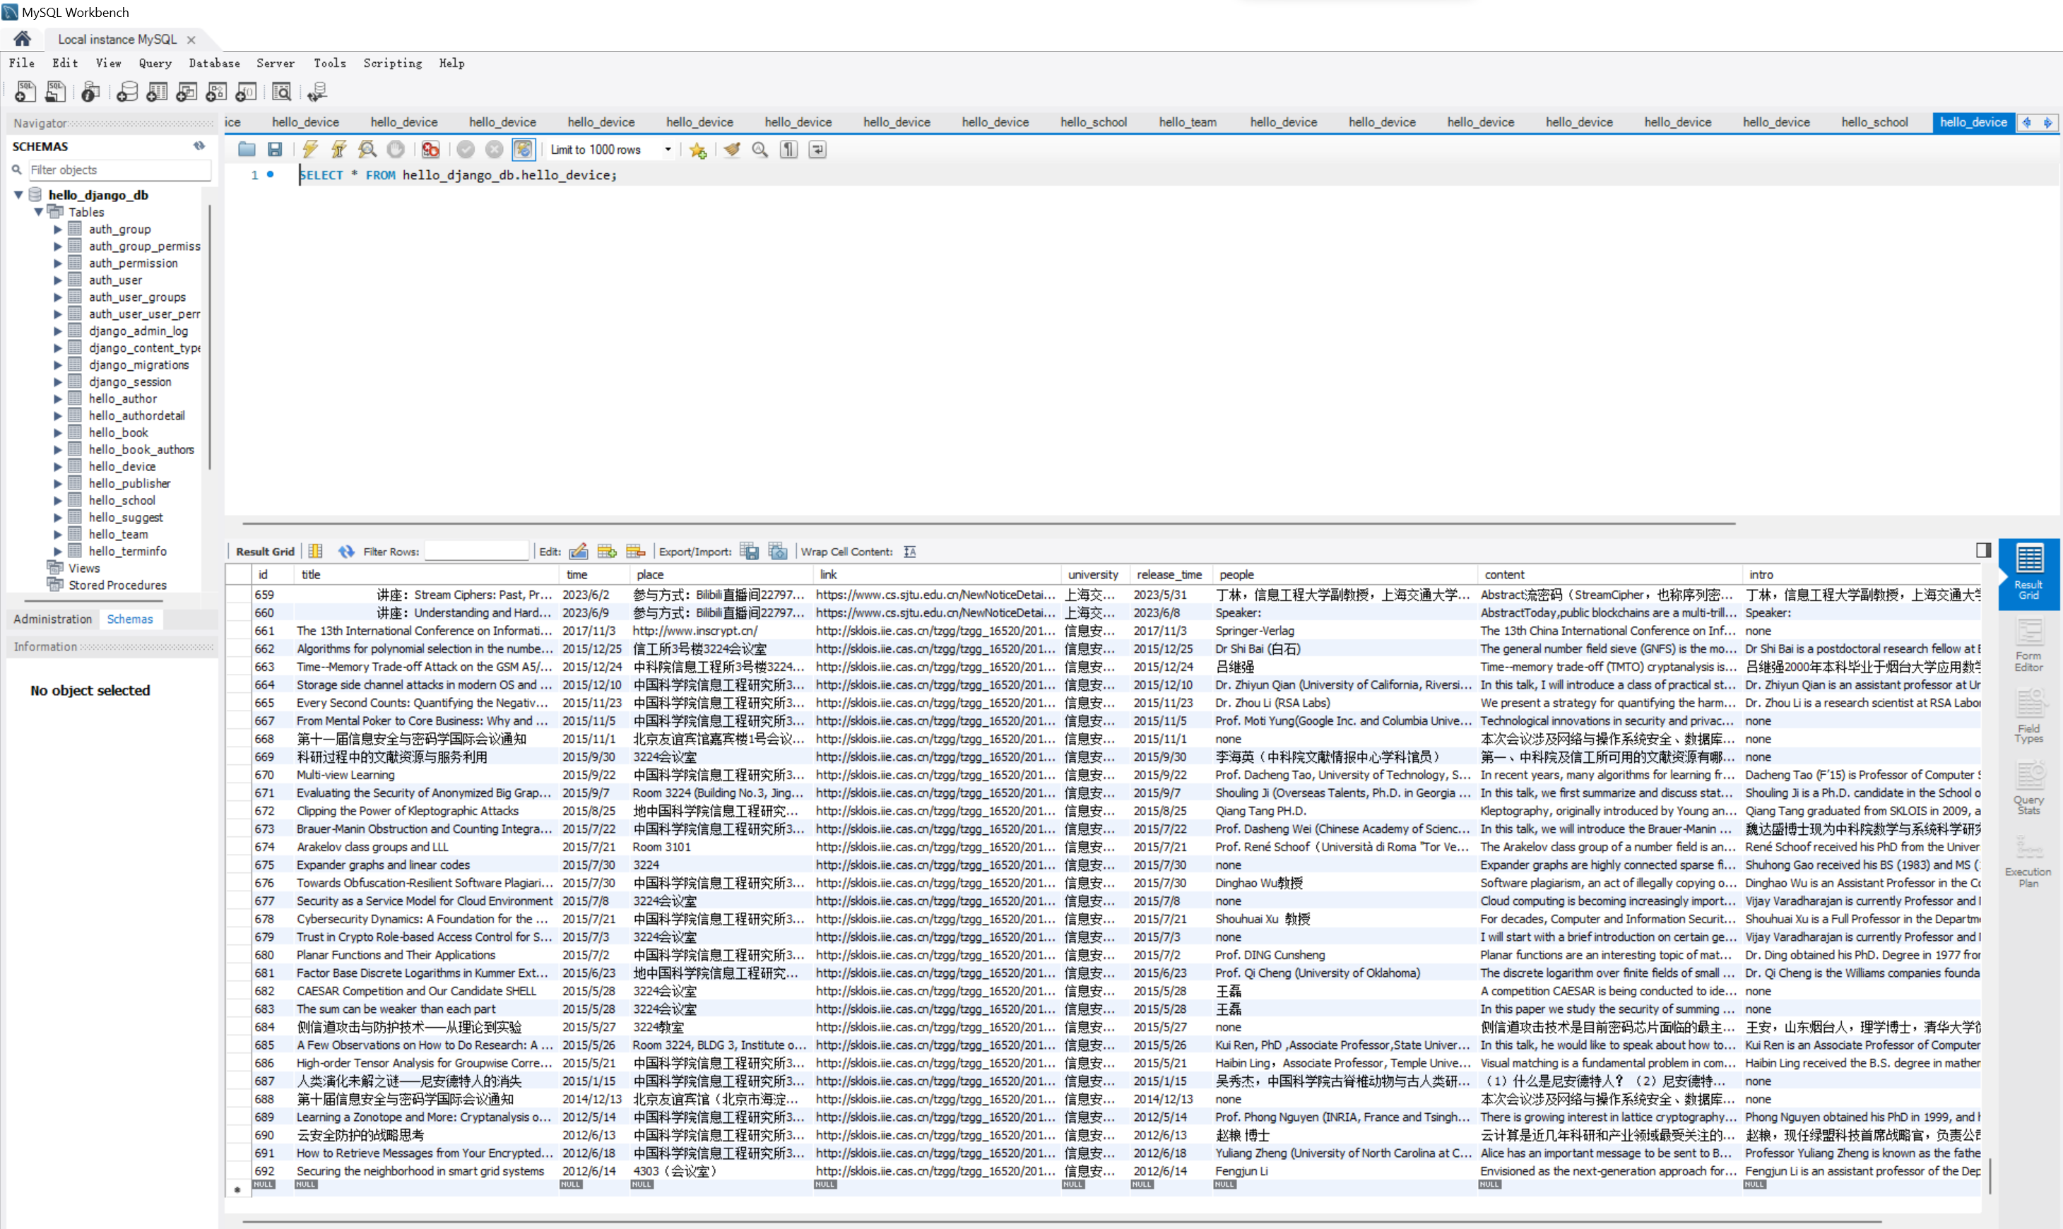

Django Framework:

Django is an advanced Python web framework that makes it possible to quickly develop secure and maintainable websites. Built by experienced developers. We use Django for our website, to facilitate the creation of our database entities, to facilitate the modification of data through back-office administration of the site, and to facilitate the use of its integrated language for web design. We link databases and web pages through the Django framework to interact front to back.

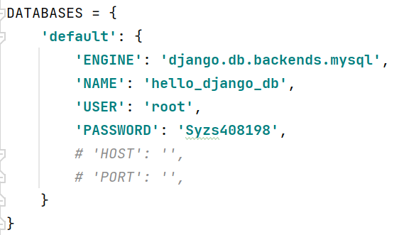

And the use of setting, urls, models, views and templates to create the site.

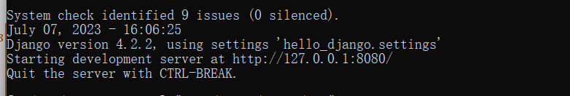

And use view to design and believe the function, to achieve the query function.

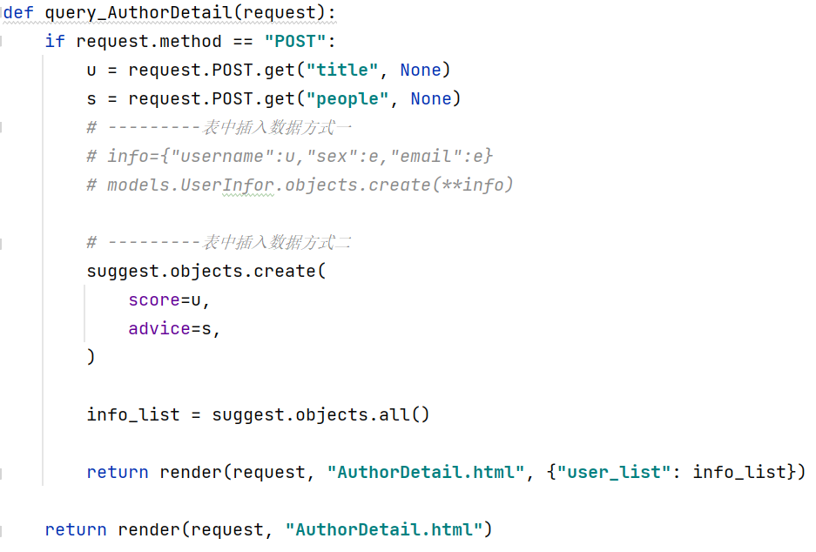

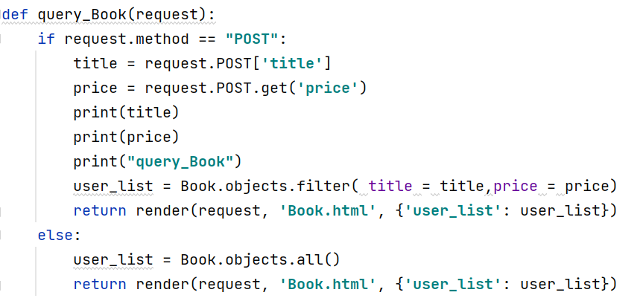

Intranet penetration:

ngrok is a reverse proxy that works by establishing a secure channel between a public endpoint and a web server running locally. ngrok can capture and analyze traffic from all channels for later analysis and playback. We use ngrok to penetrate the Intranet and transfer the Intranet to the public network so that everyone can access it.

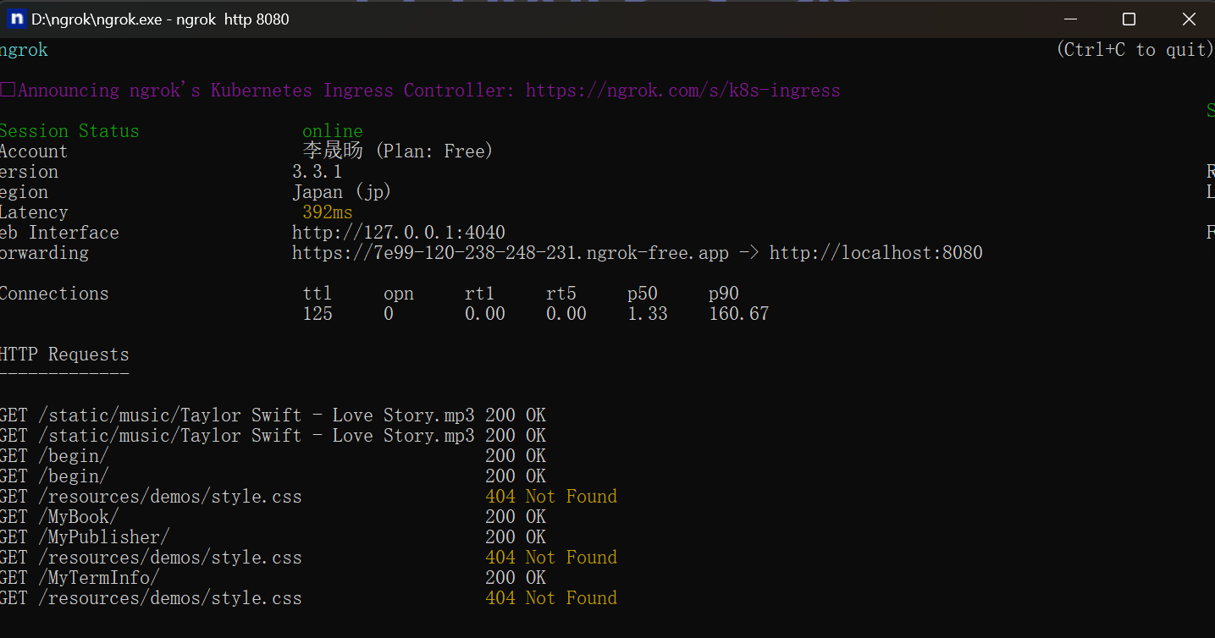

Overall construction plan:

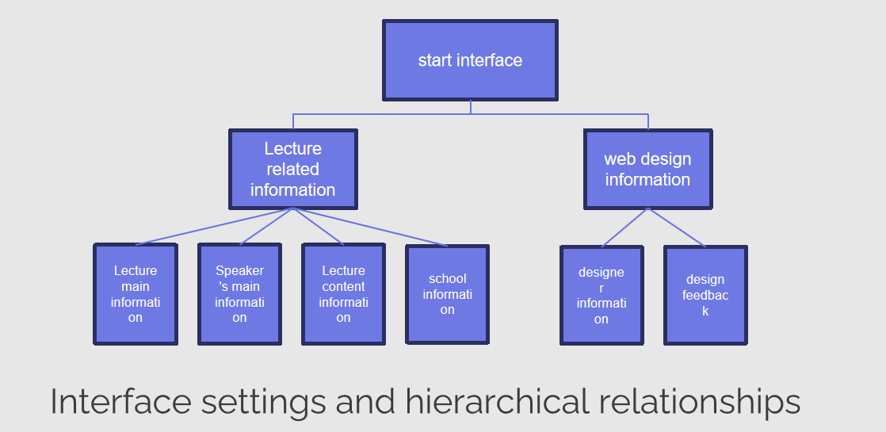

Start screen:

The beginning interface mainly displays the corresponding text information and plays the role of the opening topic. The topic we have chosen is "lecture information crawling", so the interface theme I have chosen is "Pondering". The word comes from the book of songs "such as cutting, such as polishing", the most important thing in learning and cultivation is to be able to persevere, start and finish, to achieve certain achievements, you need to have a rigorous academic attitude, excellent moral cultivation. It is in line with our purpose of listening to lectures, which is to contact more cutting-edge knowledge and discuss academia with all kinds of big coffee. At the same time, I have adopted the classic roadmap of "WELCOME TO COLORFUL COLORADO" to symbolize that academic research is moving forward like a desert. I hope you can reach the other side of your dreams with colorful dreams.

Information query interface:

Panel information

Contains the school motto of "Erudite", "careful thinking", "discernment" and "good practice", reflecting the characteristics of Chinese workers, and relevant articles will be displayed after clicking in.

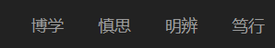

Main information of academic report

Information display:

The page mainly displays the "lecture title", "reporter", "Notice time", "report time", "report place", "link", "University", "topic" information of the lecture information. And unify the table format and the length of the internal note and the corresponding format to enhance the user's perception, redundant words are represented by ellipses, and the mouse moves to the corresponding place to display the hidden content. At the same time, links can be directed to the corresponding lecture notification.

Information query:

We set up the following query function:

a. Query the corresponding lecture information according to the lecture title or speaker information.

b. Sort lecture information according to the order of time.

c. Query lecture information based on the corresponding time range. The time period is selected in the form of a calendar table, and the corresponding time is intuitively selected

d. Search for lecture information by university name.

e. Query lecture information based on the subject.

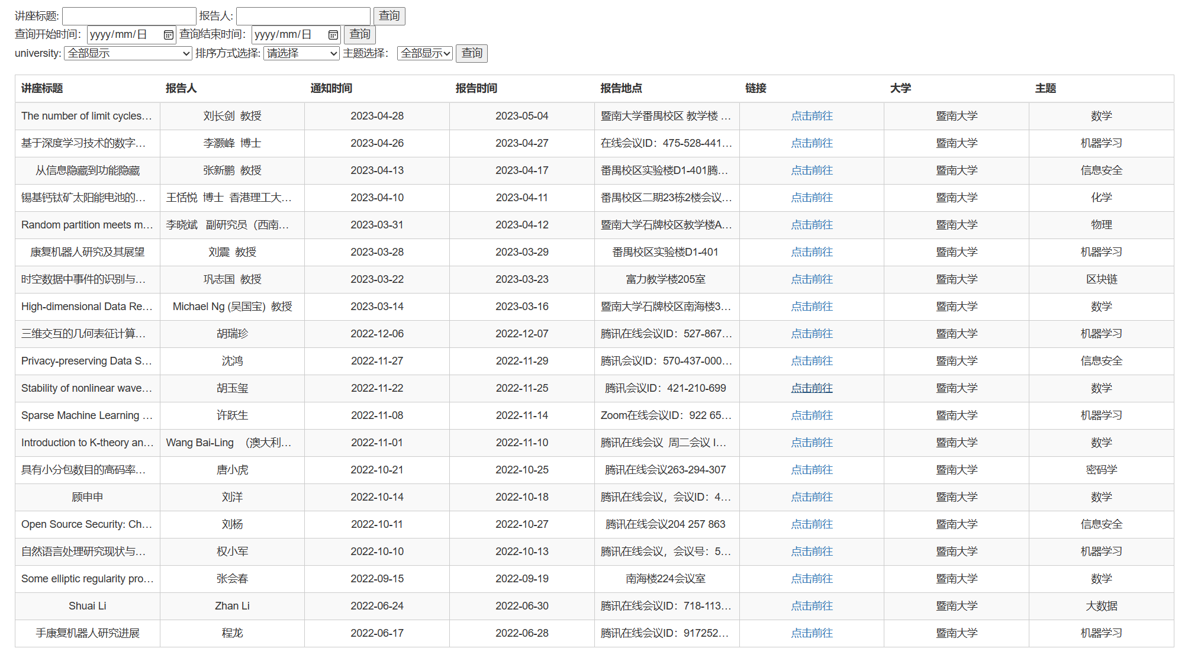

Introduction by the speaker:

Considering the general inquiry lecture, the speaker is an important factor in our consideration. Therefore, we also crawled the main introduction information of the presenter and put it into the presenter interface to facilitate the enquirer to use and enhance the understanding of the lecture.

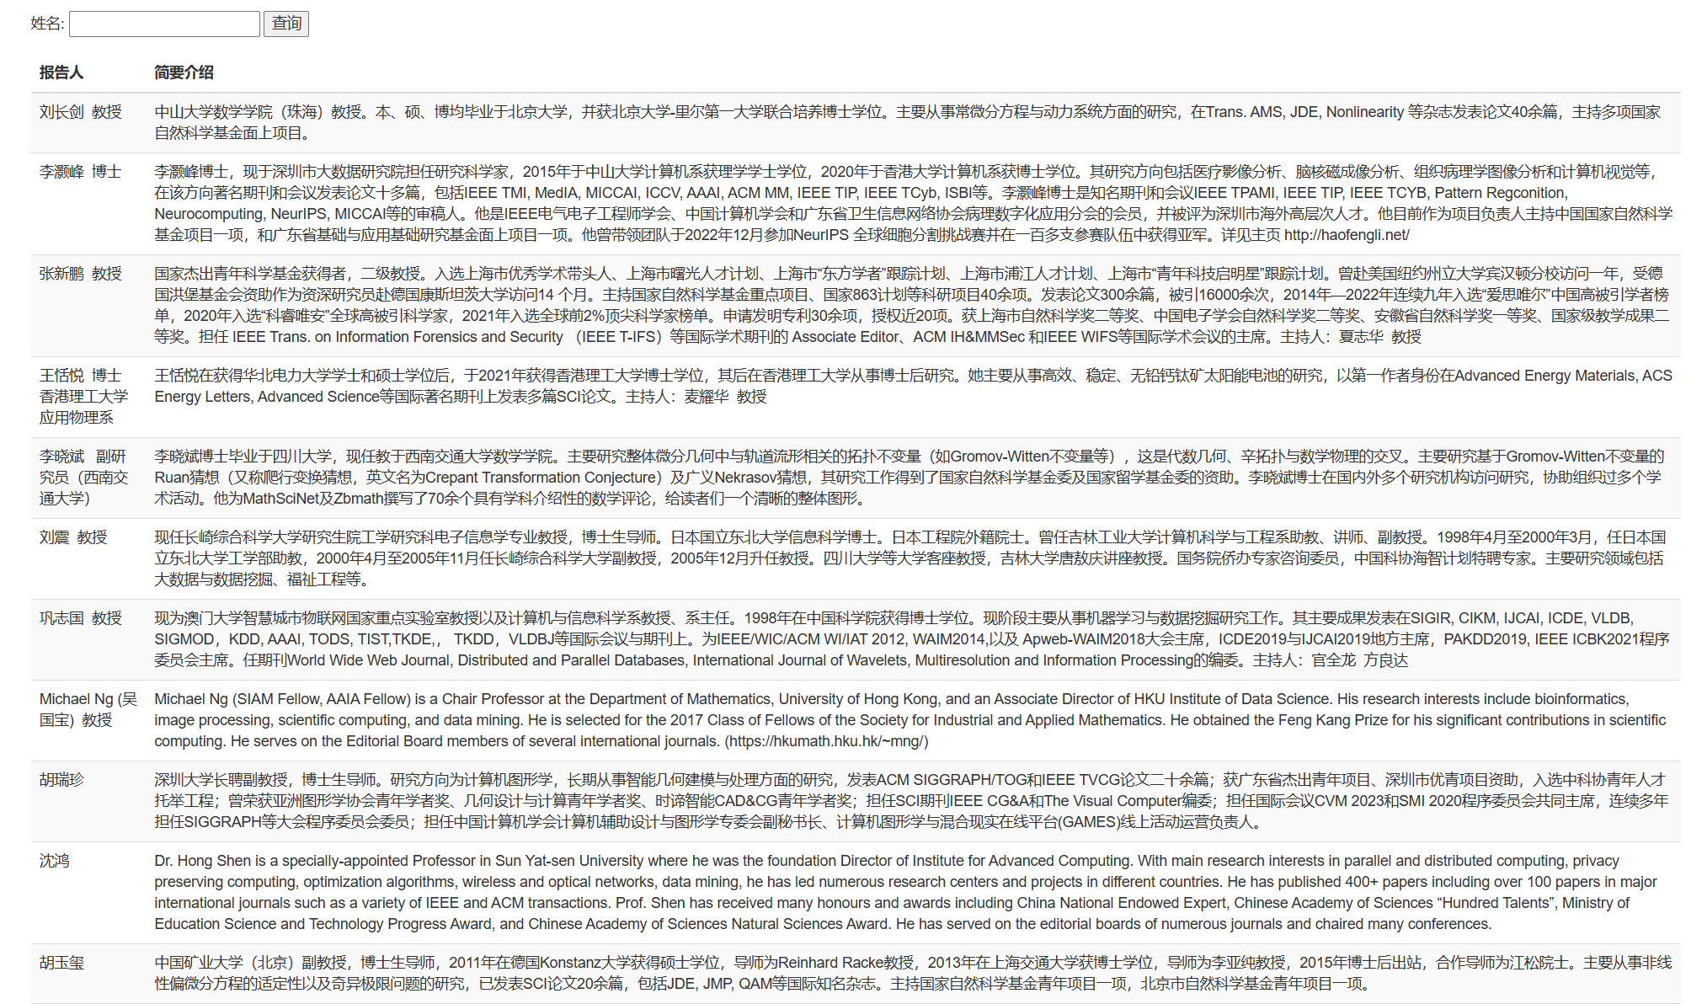

Specific content of the lecture:

Similarly, we take into account that when someone uses our website, they may not be able to access the link in a timely manner. Therefore, we also set up the specific content of the lecture, so that the enquirer can understand the specific content of the lecture in time when the Internet is not connected.

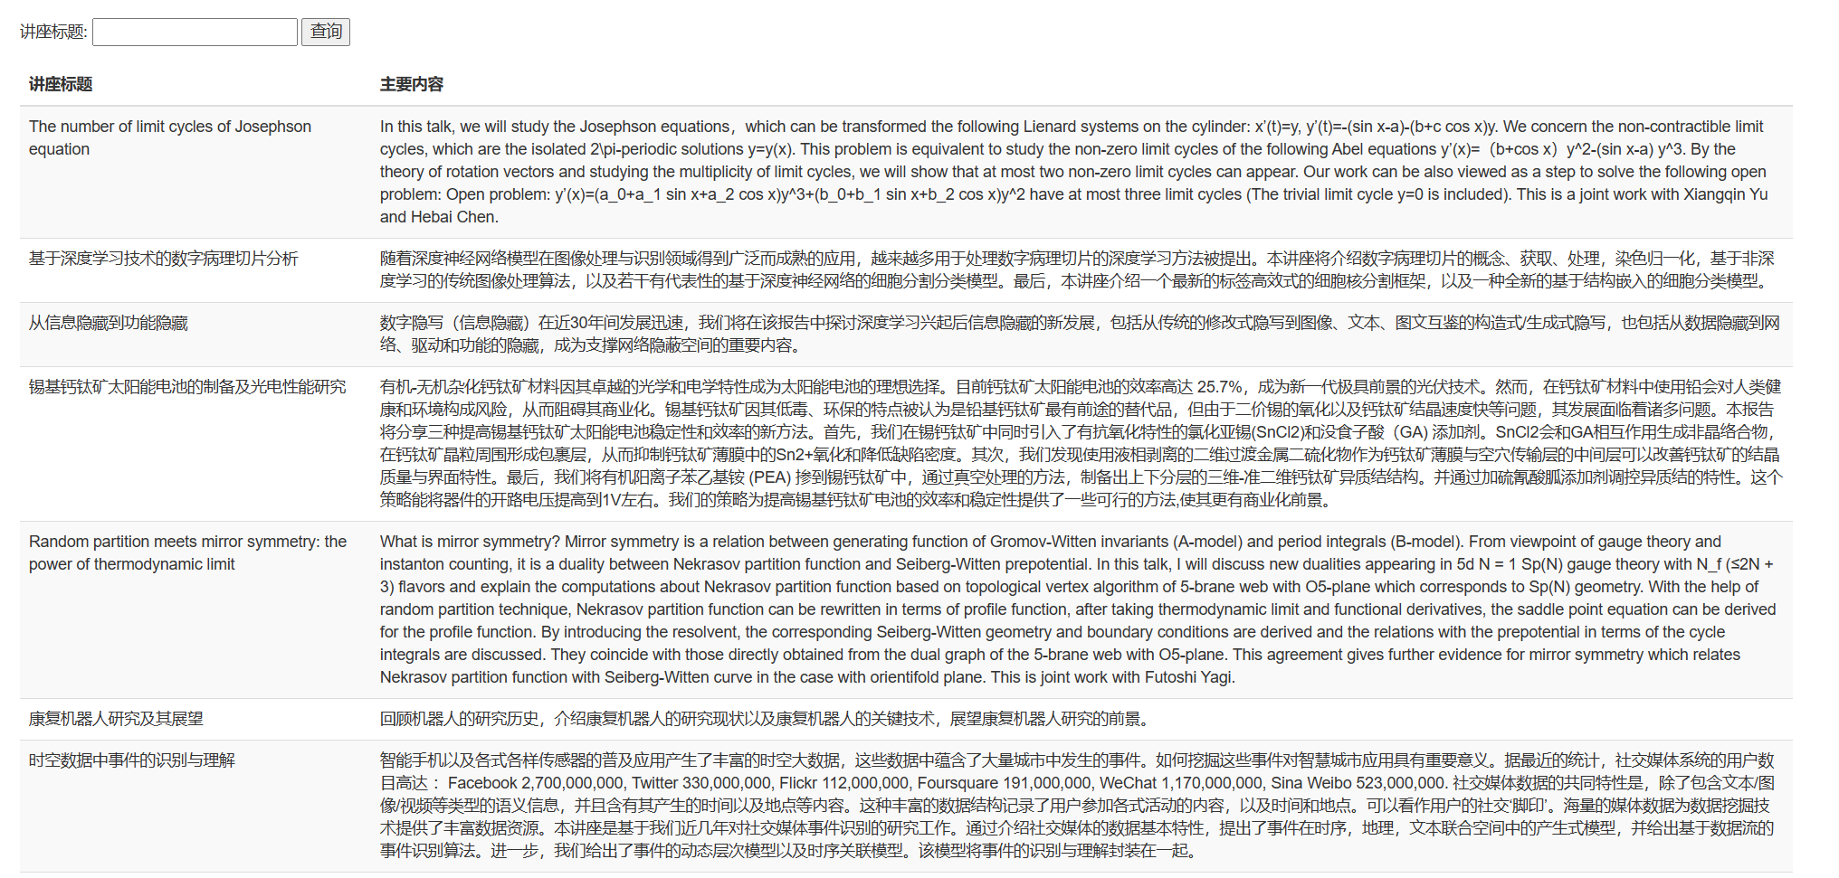

School Profile:

One of the core elements of the lecture is the location of the lecture which is the school. We also put the introduction of the school into a new interface, so that users can first understand the corresponding school, and then view the corresponding lecture information.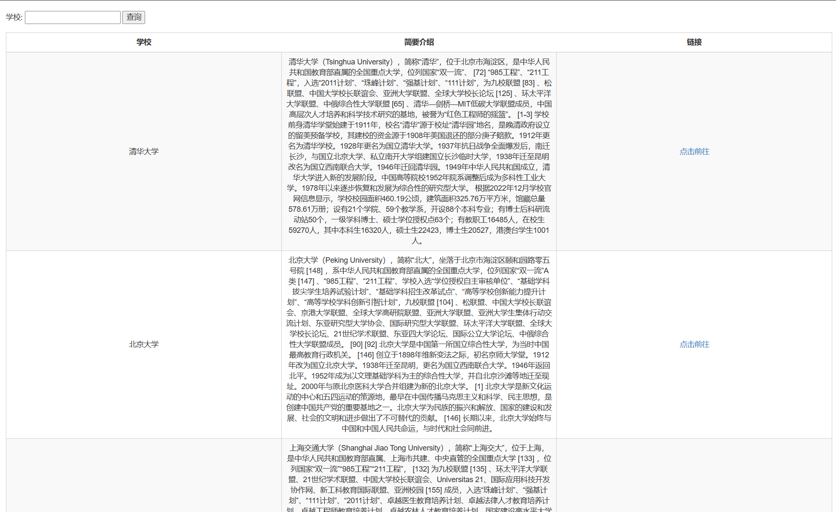

Team Information:

We joined our team for self-introduction and impressions of the big assignment.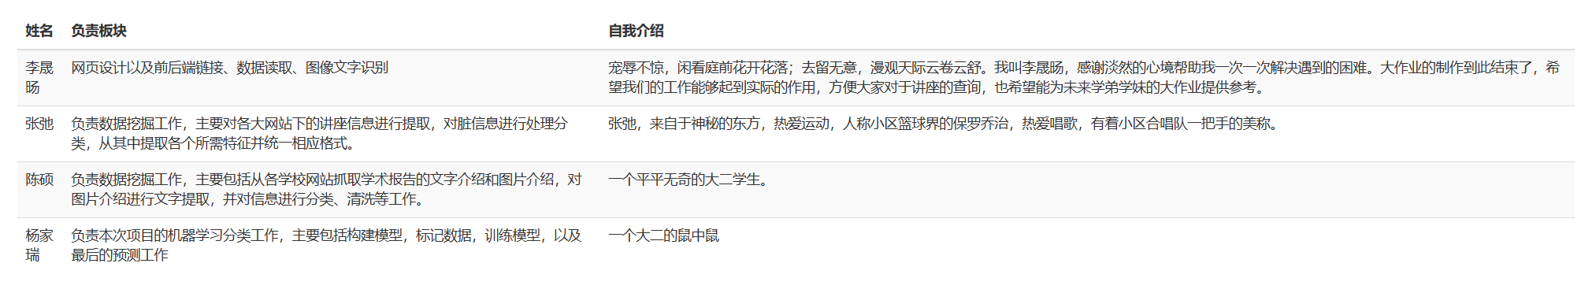

Information feedback interface:

Considering that a mature application is not limited to use, it is also very important to update and maintain later. We have added an information feedback interface to collect users' opinions on our system in a timely manner, which drives our continuous innovation.

## 3.3. Machine learning classification and algorithm design

1) Data preprocessing:

The subject is marked manually by the given data, and the data extracted is cut into training set, verification set and prediction set.

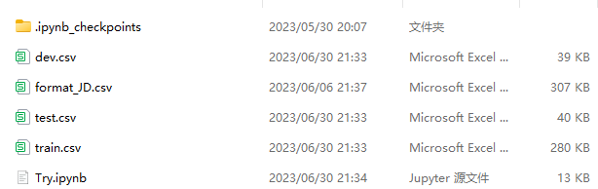

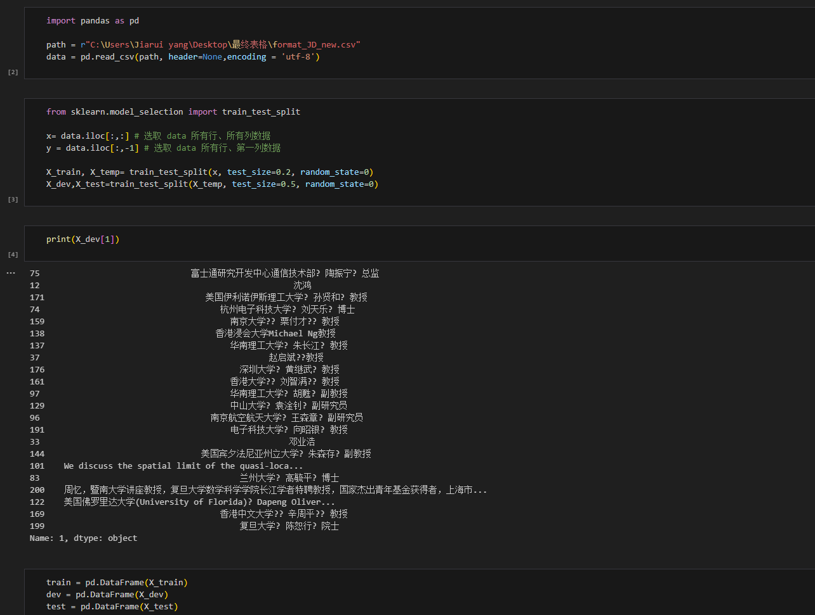

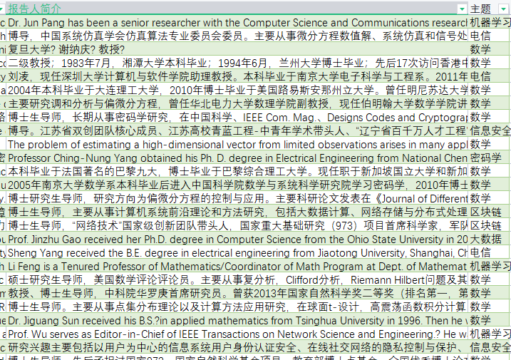

2) Selection of pretreatment model:

Considering that the maximum number of filters we conducted manually is only a few thousand, NLP learning in machine learning still belongs to small sample learning. Therefore, on this basis, we selected the fine-tuned bert model of PET paradigm suitable for small sample semi-supervised learning after reading some literatures.

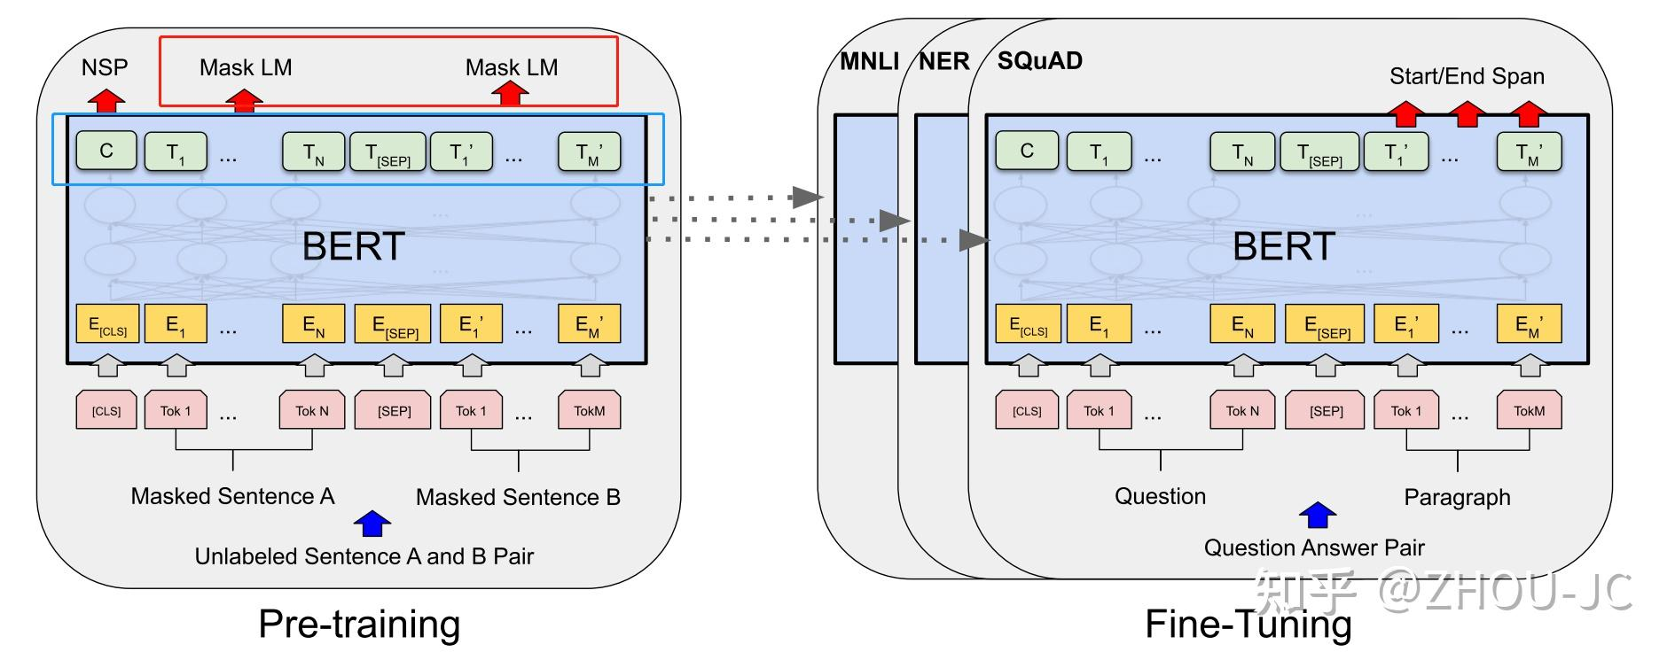

After fine-tuning the PET paradigm, it is not difficult to find that the accuracy of bert model has been significantly improved in semi-supervised learning and supervised learning.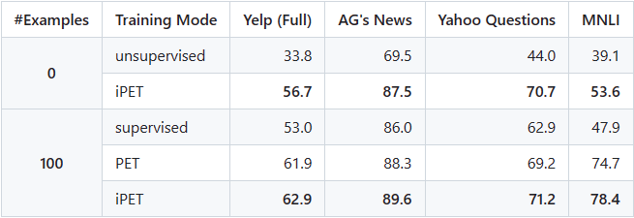

Therefore, we started the code writing of PET paradigm for our task. In this process, we need to understand that PET paradigm changes code based on different patterns, so we modified pattern based on Agnews, and loaded our processor and pvp files.

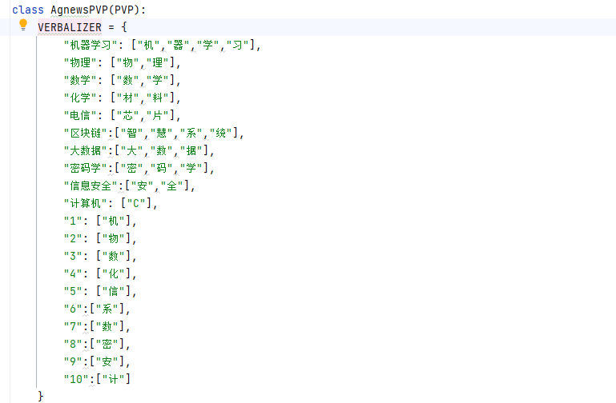

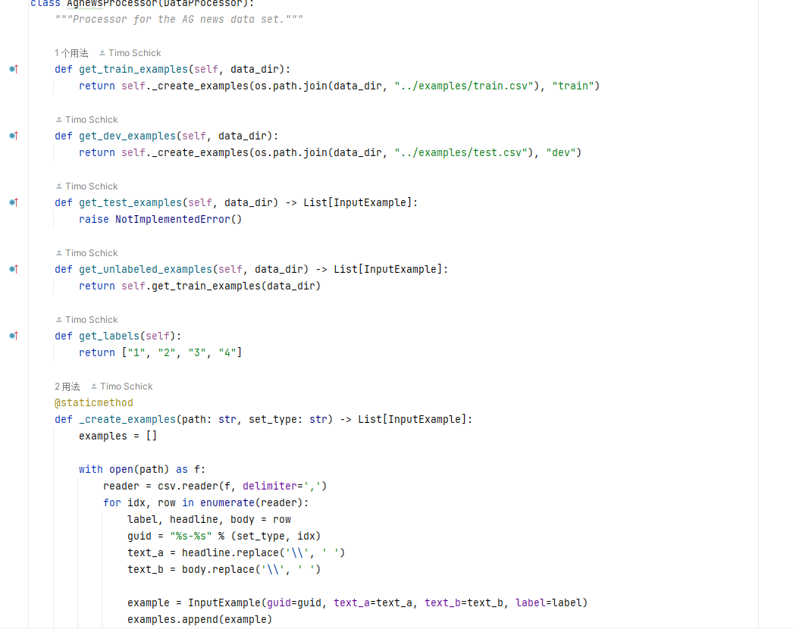

Based on this and the bert model available on the Internet, which can handle 104 languages, we trained the model.

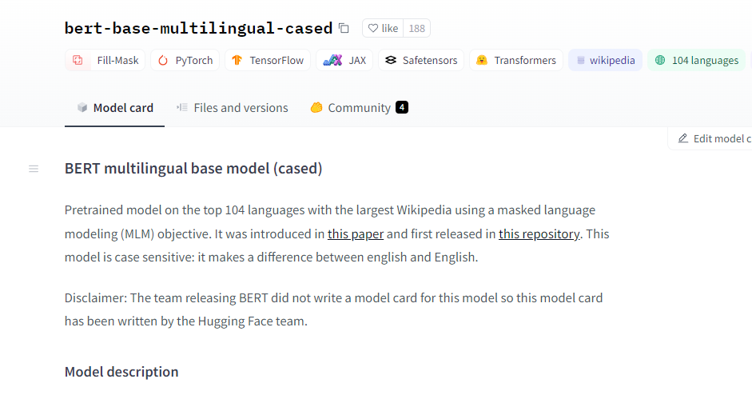

3) Model training and processing

After the code of PET paradigm was written, we started the training of the model. Unfortunately, the computer did not install anaconda or cuda before, so the training process of the model could not be accelerated by gpu, resulting in a slow training speed of the model.

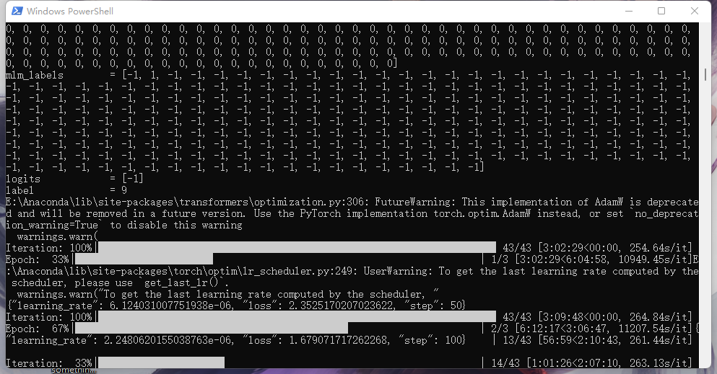

After the training is completed, we get a relatively ideal result, first of all, the tokenizer in the invariant bert model, second, the binary file of pytorch_model after training, and finally, our obtained prediction result, which is output in txt file.

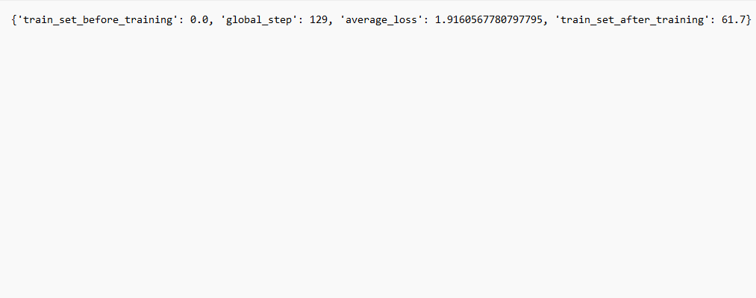

4) Model prediction

Finally, we successfully generated the output result through the fine-tuned bert model. Meanwhile, in order to avoid getting a different result every time we run in the final run, we limited the random seed in the bert model to 40. The following is our running code and the output result after the final run. It is also rendered using python to read csv files.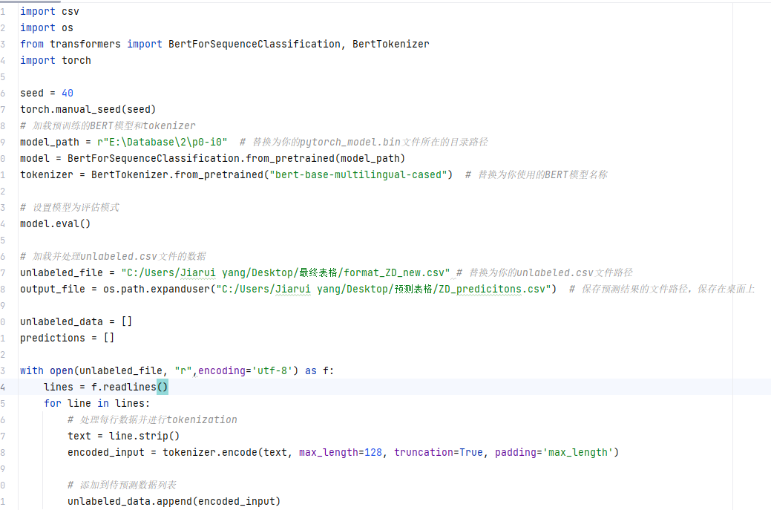 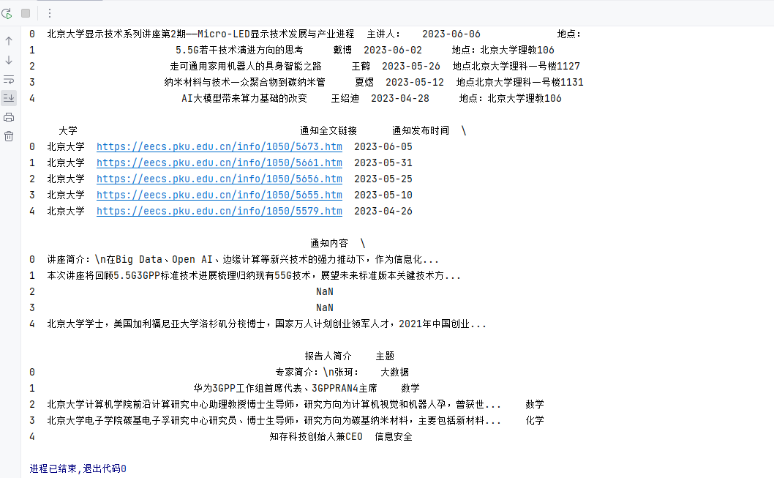

# 4 Software testing

After many tests, our software ended up with no errors, as you can see in the video below.( Right mouse open)





# 5 Software demonstration

Software Demo:

## 5.1 Display of each interface

### 5.1.1 Start screen



### 5.1.2 Main information of the academic report

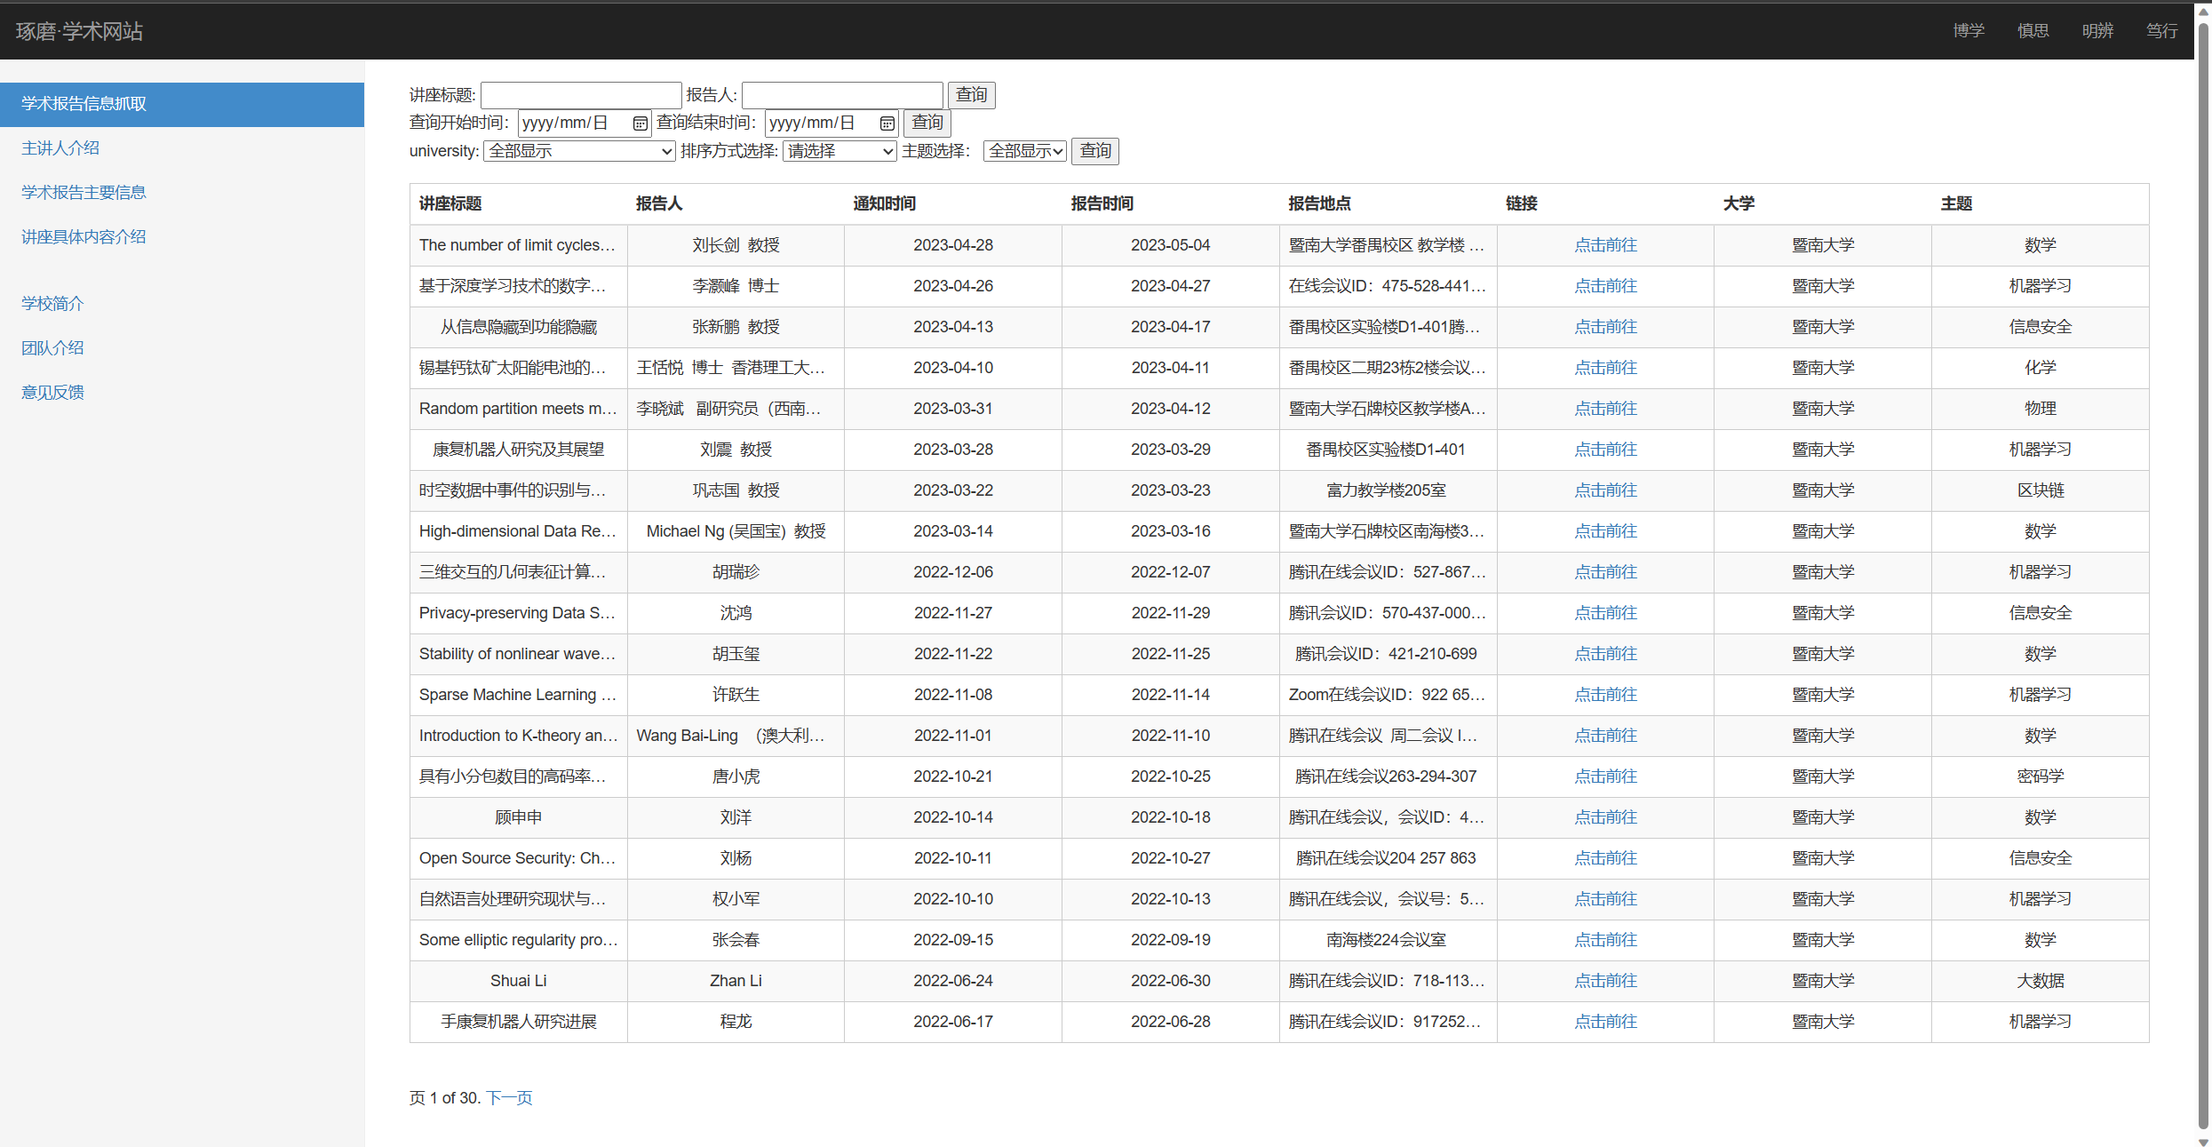

#### 5.1.2.1 Time Query

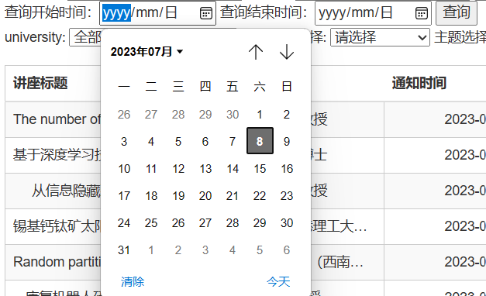

#### 5.1.2.2 School Inquiry

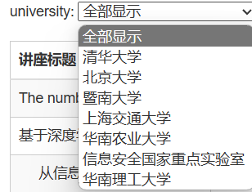

#### 5.1.2.3 Subject Query

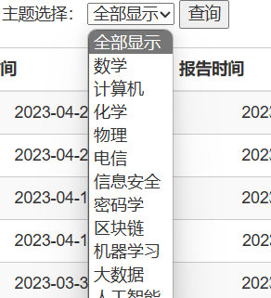

#### 5.1.2.4 Time Sorting

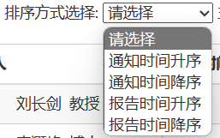

#### 5.1.2.5 Inquiry of lecture title and speaker



### 5.1.3 Presenter Information

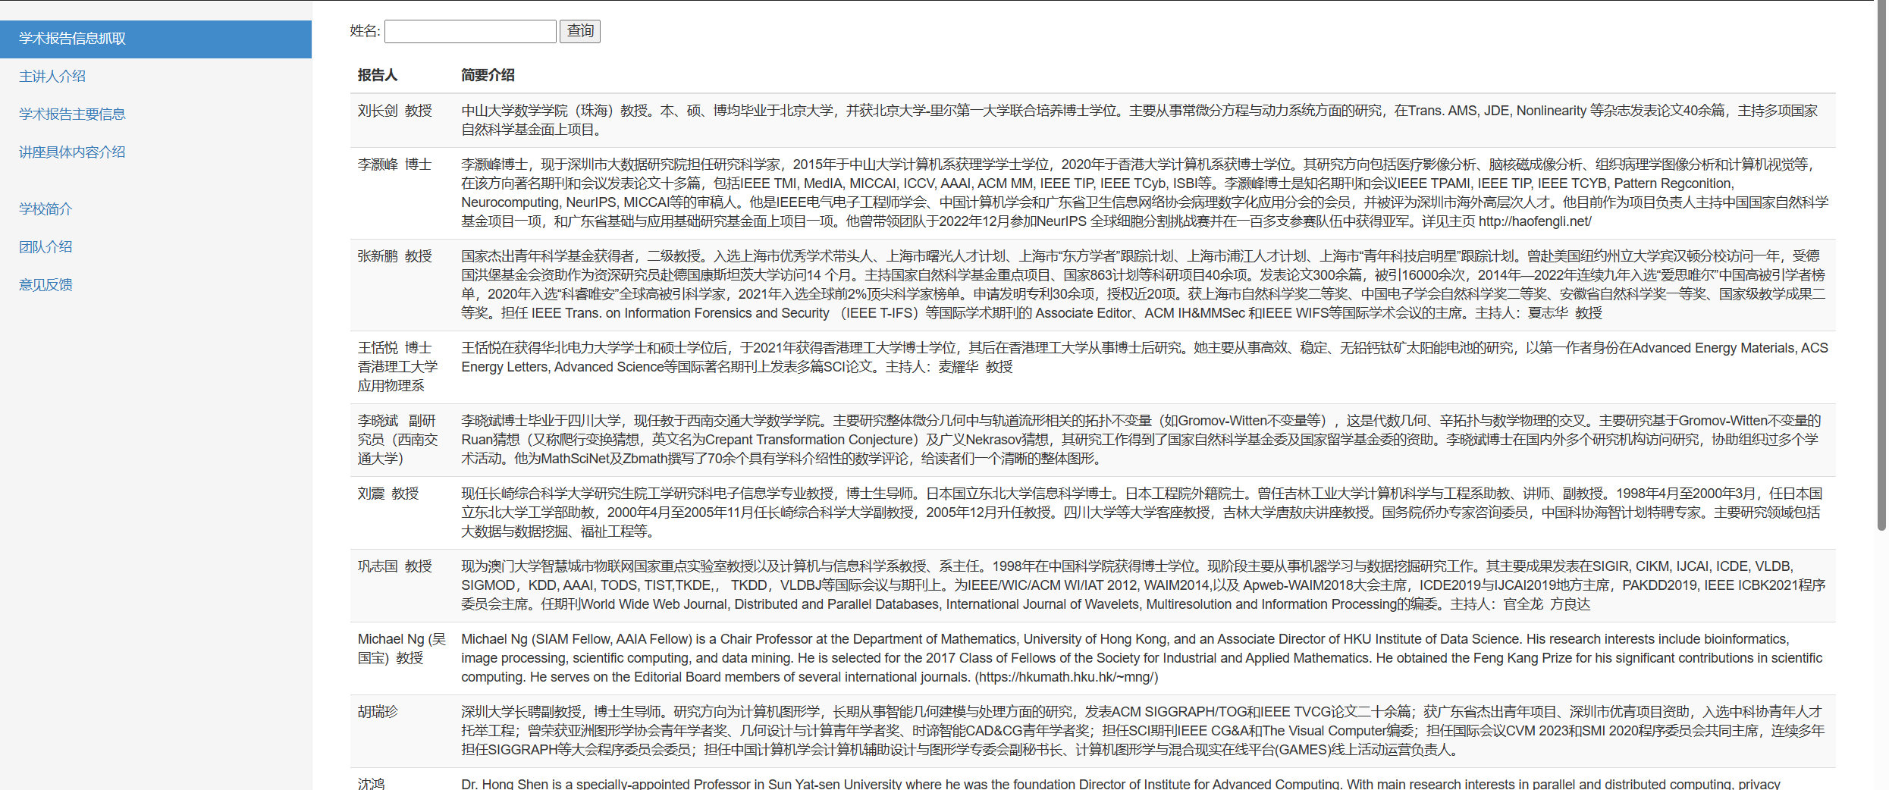

### 5.1.4 Introduction to the specific content of the lecture

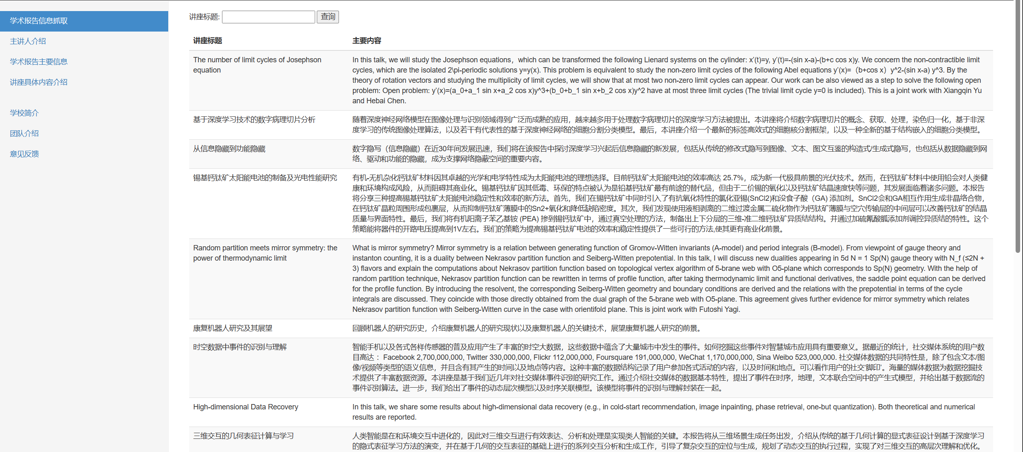

### 5.1.5 School Profile

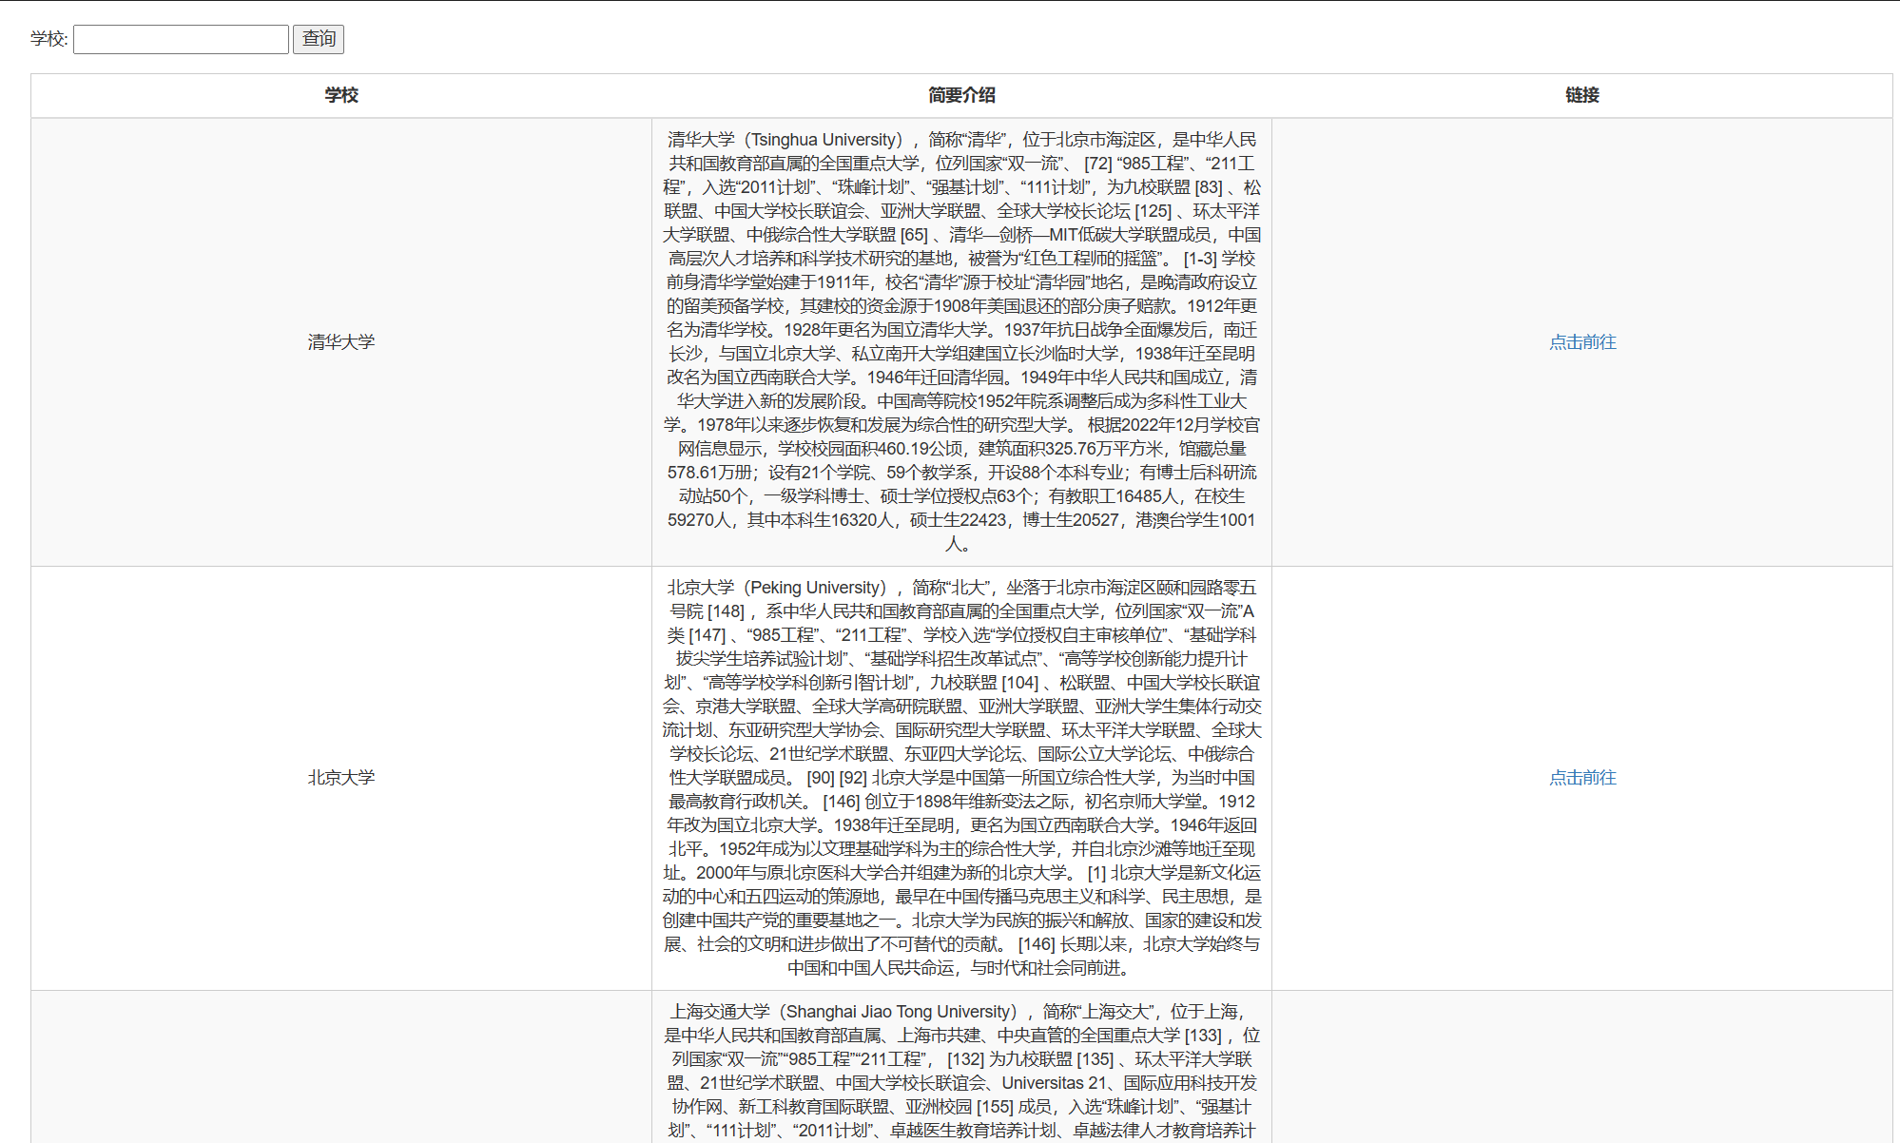

### 5.1.6 Team introduction

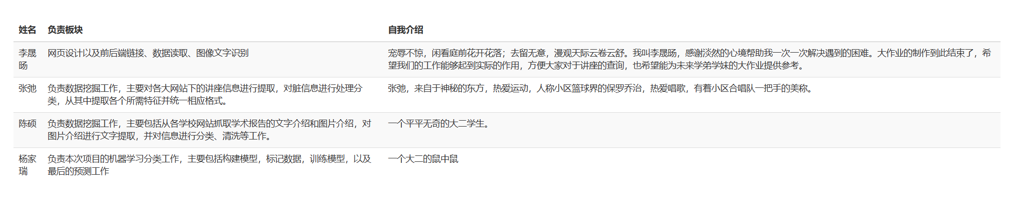

### 5.1.7 Feedback



## 5.2 Database

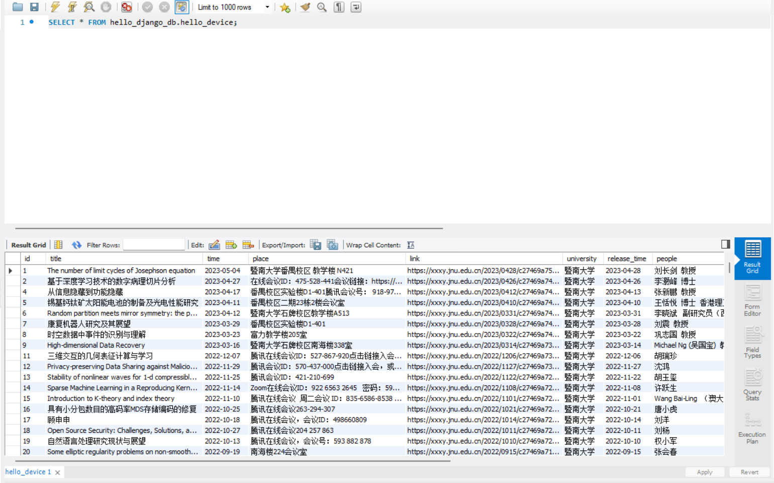

## 5.3 Django framework

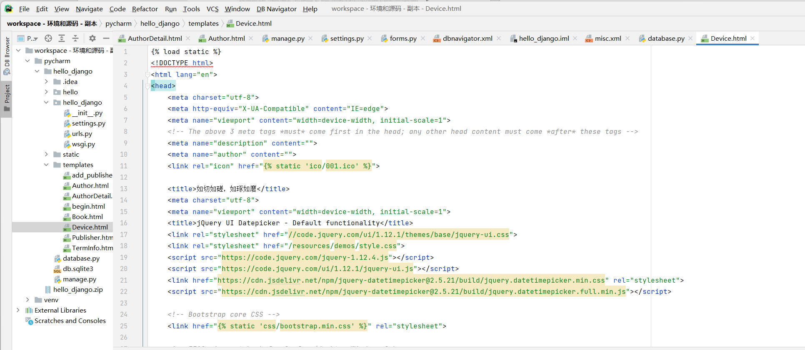

## 5.4 Intranet penetration

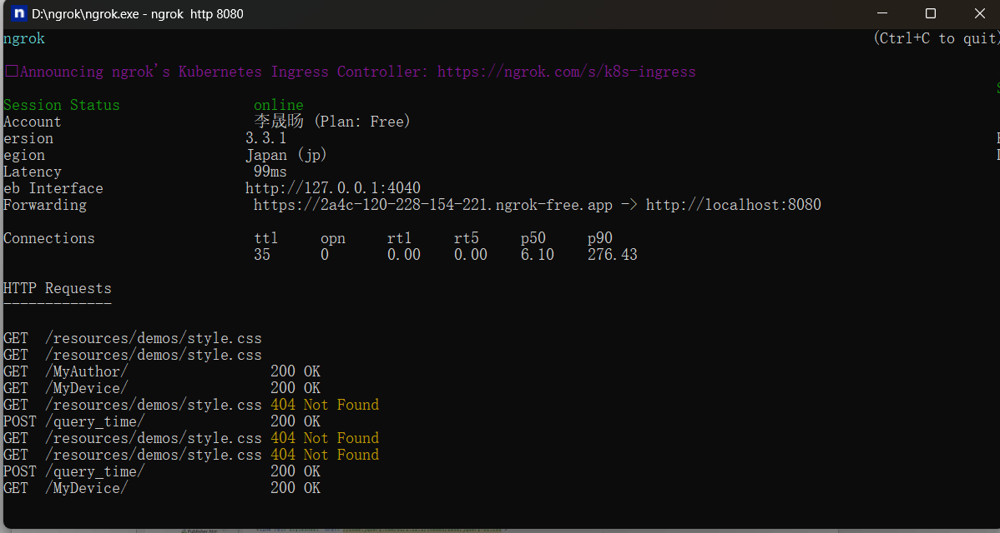

##### 5.5 Video to watch( Double click to start)



##### 5.6 Addition

Furthermore,we have made an .exe document.Once you open it,it can start to use.



And you can click the quick.exe to start.

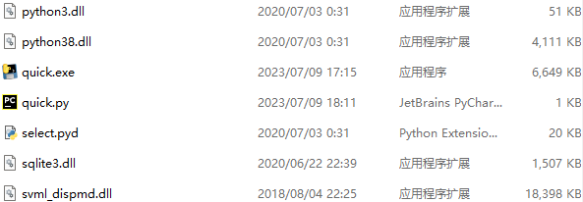

Demo:



# 6 Software use tutorial

## 6.1. Enter the website

Our website address is “<https://2a4c-120-228-154-221.ngrok-free.app/begin>”.

## 6.2. Website instructions

### 6.2.1. Start interface



Click "立即探索".

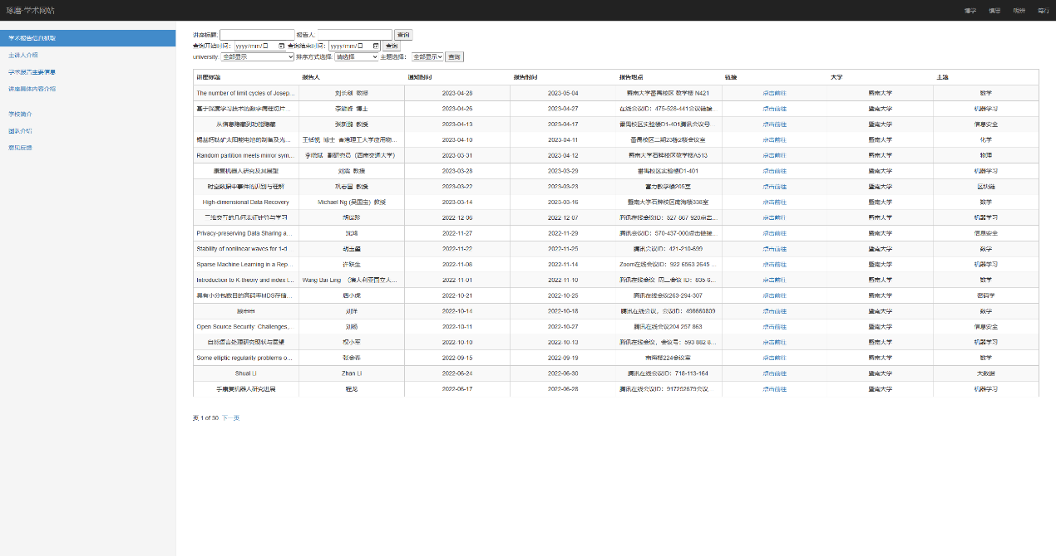

### 6.2.2. Information query interface

The left panel allows you to select the information you want to query.

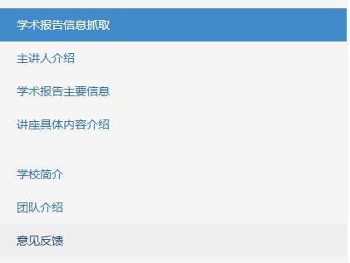

#### 6.2.2.1. Main information of academic report

##### 6.2.2.1.1. Information display

The page mainly displays the "lecture title", "reporter", "Notice time", "report time", "report place", "link", "University", "topic" information of the lecture information. And unify the table format and the length of the internal note and the corresponding format to enhance the user's perception, redundant words are represented by ellipses, and the mouse moves to the corresponding place to display the hidden content. At the same time, links can be directed to the corresponding lecture notification.

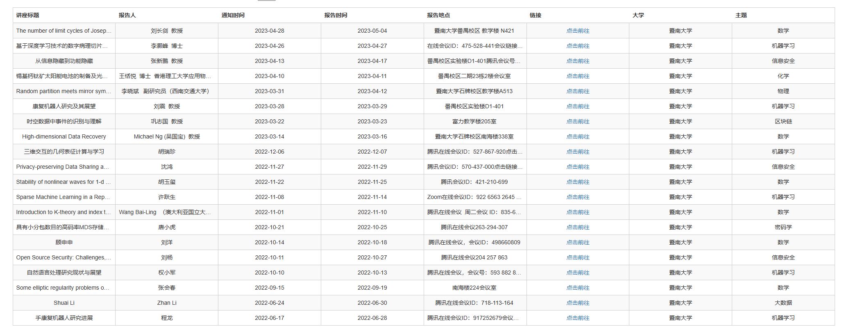

##### 6.2.2.2.2. Information retrieval

We set up the following search function:

1. Search the corresponding lecture information according to the lecture title or speaker information.
2. Sort lecture information according to the order of time.
3. Search lecture information based on the corresponding time range. The time period is selected in the form of a calendar table, and the corresponding time is intuitively selected.
4. Search for lecture information by university name.
5. Search lecture information based on the subject.

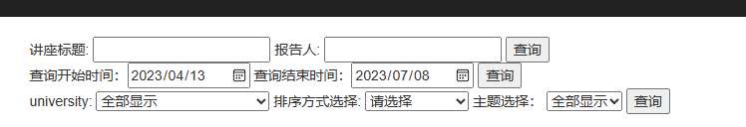

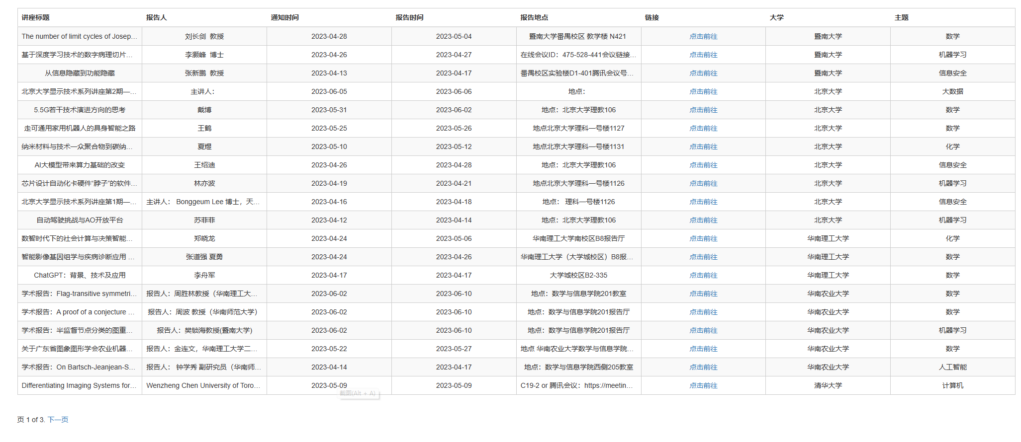

##### 6.2.2.3 Presenter introduction

You can query information about the presenter on this interface.



##### 6.2.2.4 Lecture specific content introduction

Here you can find the main content of the lecture.



#### 6.2.2.5 School profile

Information about each school can be found here.



#### 6.2.2.6 Team information

Here is the introduction of our team.



### 6.2.3 Feedback interface

Considering that a mature application is not limited to use, it is also very important to update and maintain later. We have added an information feedback interface to collect users' opinions on our system in a timely manner, which drives our continuous innovation.

# 7 Summary of group discussion

## 7.1. First group discussion

Date: April 17, 2023

Time: 20:00-21:00

Location: 2nd floor, d5g

List of topics:

1. Select items to discuss

2. Project demand analysis

Topic 1: Select items for discussion

Time: 20:00-20:30

Discussion:

- Li Shengyang listed many projects and put forward his own opinions on each project.

- Chen Shuo and Zhang Chi expressed interest in the two topics of Daily Foundation and information capture of academic report lectures, and discussed the difficulty of their completion and possible problems.

- Yang Jiarui put forward his own views, and the group of four discussed and decided.

- Finally, the group decided to further evaluate the specific objectives of the project with the division of work in the group.

Topic 2: Project requirements analysis

Time: 20:30-21:00

Discussion:

- Li Shengyang proposed to discuss the objectives and division of labor according to the task book.

- Yang Jiarui watch the provided video proposal to find innovative points.

- Discussion of demand innovation focuses on Intranet penetration and machine learning classification.

- Eventually, the group reached a consensus and decided to make a detailed division of labor plan and will discuss the progress at the next meeting.

Action matters:

- Chi Zhang and Shuo Chen will be responsible for data crawling and normalization.

- Yang Jiarui will be responsible for the task of machine learning classification.

- Shengyang Li will be responsible for the construction of the website and the front and back end links.

Concluding remarks:

This discussion session focused on the selection of projects and how they should be carried out. Through discussion and decision-making, the group identifies needs and divides tasks, and develops a plan of action for the next step.

Summary Author: Yang Jiarui

Date: April 17, 2023

## 7.2. Second group discussion

Date: June 6, 2023

Time: 20:00-21:00

Location: 2nd floor, d5g

List of topics:

1. Second defense discussion

2. Project progress discussion

Topic 1: Second defense discussion

Time: 20:00-20:30

Discussion:

- Yang Jiarui reminded the time of the second defense and raised questions about the work to be reported.

- Li Shengyang said what he has completed at present, and decided that everyone make their own ppt to facilitate the combination of reports.

- Chen Shuo and Zhang Chi presented the results of crawler, and Zhang Chi proposed to complete the first midterm defense by himself.

- Finally, the Group decided to discuss the progress of the project further.

Topic 2: Project progress discussion

Time: 20:30-21:00

Discussion:

- Yang Jiarui raised the current difficulties encountered in unsupervised learning and the problem that the models used are not ideal.

- Chen Shuo proposed that semi-supervised learning of small samples can be manually labeled.

- Li Shengyang said that his website production has a direction and can be completed in the next week.

- Zhang Chi showed and Chen Shuo's crawler results and said that the current direction of work in the area of image recognition.

- In the end, the group reached a consensus and decided to make a detailed division plan, and will discuss the final defense at the next meeting.

Action matters:

- Zhang Chi and Chen Shuo will look for an api interface for picture text extraction.

- Jiarui Yang will be responsible for finding and changing data tags and models.

- Shengyang Li will be responsible for website construction and Intranet penetration.

Concluding remarks:

This discussion session mainly discussed the things needed for the second defense and the tentative progress of the project. Through discussion and decision-making, the group determines the way forward and develops a plan of action for the next step.

Summary Author: Yang Jiarui

Date: June 6, 2023

## 7.3. The third group discussion

Date: June 26, 2023

Time: 20:00-21:00

Location: 2nd floor, d5g

List of topics:

1. Final defense discussion

Topic 1: Final defense discussion

Time: 20:00-20:30

Discussion:

- Li Shengyang showed the website that integrated all the results, and tested it, and got the ideal result.

- Yang Jiarui demonstrated his prediction process, explained the principle and wrote the defense draft of this part.

- Chen Shuo and Zhang Chi reviewed the assignment book and results, and made a division plan for ppt and practical training documents.

- Finally, the group decides on the results that need to be presented for the final defense.

Action matters:

-Chi will be responsible for the ppt integration.

-Yang Jiarui will be responsible for completing his own ppt module and defense draft, as well as writing the training report.

-Shengyang Li will be mainly responsible for the defense and his own ppt module.

- Chen Shuo will be responsible for improving the format of some data in the database and completing the ppt of the crawling part.

Concluding remarks:

This discussion session mainly discussed the preparation of the final defense. Through discussion and decision-making, the group determines the way forward and develops a plan of action for the next step.

Summary Author: Yang Jiarui

Date: June 26, 2023

# 8 Personal Summary

Yang Jiarui: This training impressed me deeply. With the efforts of our team, we made a real product, although it was still very rough, but it could already be used by the outside world, and it was the first time to experience various details of software engineering. From the perspective of users, meeting minutes and frame drawings should also be recorded in the training documents. I have benefited a lot from them, and in the process of completing my own tasks, I have also mastered how to carry out the work of a natural language processing model and how to learn from other people's models to complete my own model training and processing.

Zhang Chi: Through the joint efforts of me and other team members, we have successfully developed an academic lecture information website that everyone can use. Although the website currently has some shortcomings, I am also very excited and proud. During this period, I was mainly responsible for collecting and cleaning lecture information, as well as extracting relevant features. In order to complete the task, I learned and mastered the relevant structure of web pages, and gained background knowledge and related operations in information retrieval. In addition, I also mastered the ability to extract key features from Dirty data, which also made me feel the importance of a good copy of data to the whole work. This database training was also a very unforgettable experience for me.

Chen Shuo: In this database project, my main responsibility was the data mining part. I have successfully carried out tasks such as data mining, data cleaning, and image text recognition, so I am relatively satisfied with my work.

During this process, I encountered many challenges. For example, I had to scrape information from websites with different formats and clean up the messy data. I also had to find ways to accurately extract text from images. I managed to overcome these difficulties one by one and ultimately provided reliable data sources for my teammates working on the database.

Of course, there are still many areas for improvement in this project. The accuracy of the data could be increased, and a larger sample could be obtained through web scraping. As a result, this project not only deepened my understanding of databases and data mining, but also made me realize my shortcomings and the importance of teamwork.

Li Shengyang: No surprise, see the court before the flowers bloom; Go to stay unintentionally, diffuse view the sky cloud rolls cloud shu. My name is Li Shengyang, thank you for helping me to solve the difficulties I encountered again and again. This is the end of the production of the big homework, I hope our work can play a practical role, to facilitate everyone's inquiry for the lecture, but also hope to provide a reference for the future of the big homework.

# 9 Project schedule

Task 1: Crawler and data processing

Responsible person: Chen Shuo and Zhang Chi

Start date: April 20, 2023

Completion date: June 22, 2023

Task two, website construction and front and back end links

Person in charge: Li Shengyang

Start date: April 18, 2023

Completion date: June 24, 2023

Task 3: Machine learning classification and prediction

Person in charge: Li Shengyang

Start date: April 21, 2023

Completion date: June 23, 2023